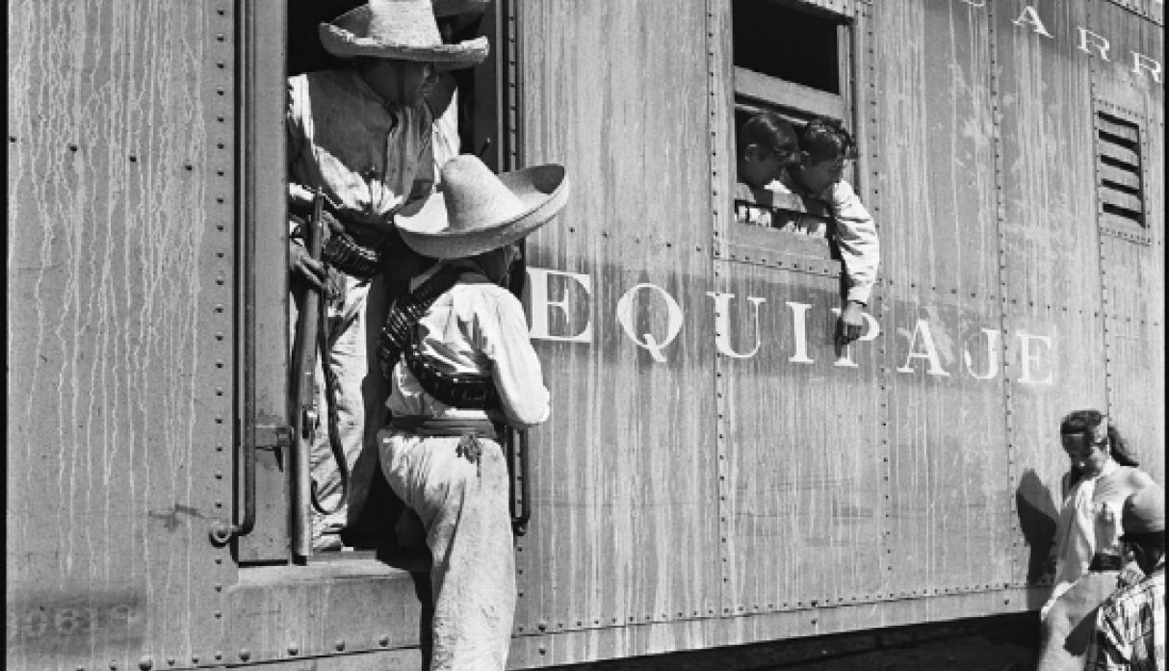
Photo by Juan Rulfo, in Juan Rulfo, En los ferrocarriles
(Mexico City: Fundación Rulfo | UNAM | Editorial RF, 2016)

Spanish 325: Moving Stories
Spring 2023 - Dr. Lisa M. Rabin
Asynchronous online

lrabin@gmu.edu
Office Hours TBA

Part 1: Course information

Course description:
This Mason Core course in Literature, taught in English, introduces students to Latin American and Latino/a/x narrative works through the lens of migration. We will explore migration topics in a range of storytelling formats: the coming-of-age and historical novel, the short story, oral history, memoir, comics, telenovela, dramatic and documentary film. Students will have the opportunity to locate these narratives in their historical and social contexts, and consider ways in which they add to our understanding of historical and contemporary migration processes and policies. As a Mason Core course in literature, SPAN 325 will also guide students in learning current cultural-analytic approaches to the study of literature, comics, televisio and film as they also develop their abilities in close reading, critical writing and discussion.

Course materials:
The following ENGLISH-language editions of these texts are required and available in George Mason’s bookstore. There will be additional readings for free on Blackboard.

- Mario Vargas Llosa, The Storyteller [available to read for free at archive.org]

- Maria De Los Reyes Castillo Bueno and Daisy Rubiera Castillo, trans. Anne McLean, Reyita: The Life of a Black Cuban Woman in the Twentieth Century (Durham: Duke UP), 2000. ISBN-13: 978-0822325932 | ISBN-10: 0822325934.

- Rómulo Gallegos, trans. Robert Malloy, Doña Bárbara. [available to borrow on a one-hour basis at archive.org] OR to buy in the bookstore: Chicago: U of Chicago P, 2012, ISBN: 9780226279206.

- Gabriel García Márquez, 100 Years of Solitude (trans. Gregory Rabassa) [available to read for free at archive.org]

- Juan Rulfo, Pedro Paramo [available to read for free at archive.org]

- Frederick Louis Aldama, ed., A Latinx Comics Anthology (Columbus: Mad Creek Books, 2018). ISBN-10: 0814254934 | ISBN-13: 978-0814254936.

Recommended:
I will be making recommendations for supplemental films and TV shows on Netflix (as well as YouTube and our library’s website); a Netflix account is recommended.

Calendar (tentative)
There may be circumstances that necessitate changes to the calendar.

Module 0
Introductions. What is the shape of stories, and how do they shape culture?
How can the general features of narrative storytelling help us approach the specific stories of Latin Americans and US Latinx?

Course activity [Bb]

Module 1
Back to origins. Who tells the stories of Latin America – and why does it matter?

Mario Vargas Llosa, The Storyteller

Course activity [Bb]

Module 2
From slavery to freedom to revolution.
Reyita: The Life of a Black Cuban Woman in the Twentieth Century

Course activity [Bb]

Module 3
“Order and Progress” -- and displacement.
The Gaucho Juan Moreira [Bb]

Course activity [Bb]

Module 4 – week of September 21
From the city to the country:
nation-building and cultural nationalism in Doña Bárbara.

Course activity [Bb]

* Write and turn in your first analytical essay – week of September 28*

Module 5
Moving the hemisphere towards its ideals: reading TBA.

Course activity [Bb]

Module 6

History repeats itself.
100 Years of Solitude

Course activity [Bb]

Module 7
Deception and displacement in the Mexican Revolution.
Pedro Páramo

Course activity [Bb]

Module 8
From the country to the city: reading TBA.
Course activity [Bb]

* You’ll write and turn in your second assignment this week *

Module 9
Coming of age in the Latinx US: reading TBA

Course activity [Bb]

Module 10
Borders: reading TBA

Course activity [Bb]

Module 11

Optional course activity

Módulo 12
Moving stories in comic art:
A Latinx Comics Anthology

Course activity [Bb]

*Final creative project due the day of the final*

