TEMPTRESS: RACE, SEX, AND POWER
Fall 2019
Thursday 4:30 pm - 7:10 pm
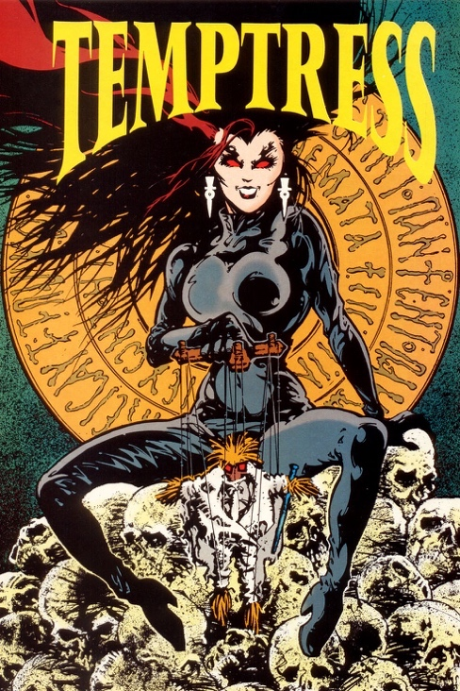

Welcome!
I am looking forward to being your instructor this semester. In order for this to be a great class for both of us, I need you to understand the importance of keeping me informed of your needs and challenges.

Instructor communication policy: I am available to hear your concerns, to discuss course topics, and to provide strategies for your academic success. Feel free to come by my office anytime. If my door is open, just stop on in to chat, I would love to see you. Or, if you would like to schedule an appointment, please let me know and we can work out a time to meet (Starbucks is great), a phone call via Google Voice, or a live ZOOM conference call. If you would like to schedule a Google Voice or ZOOM meeting with me, send me an email with three date/time options that you are available.

I will respond to your email inquiries within 24 hours during the week (Monday through Friday). I do my best to be responsive on the weekends, but I am human and need a bit of rest and relaxation with my family. Let’s make this a great semester!

Instructor: Dr. Wendi Manuel-Scott
Office Location: School of Integrative Studies, 407 Enterprise Hall
E-mail: wmanuels@gmu.edu | SIS Web: http://integrative.gmu.edu
Call or Text me via Google Voice: (703) 249-9094
Office hours by appointment.

“The academy is not paradise. But learning is a place where paradise can be created. The classroom with all its limitations remains a location of possibility. In that field of possibility, we have the opportunity to labour for freedom, to demand of ourselves and our comrades, an openness of mind and heart that allows us to face reality even as we collectively imagine ways to move beyond boundaries, to transgress. This is education as the practice of freedom.” -bell hooks

“….We must move against not only those forces which dehumanize us from the outside, but also against those oppressive values which we have been forced to take into ourselves.” – Audre Lorde

Course Description
This course examines the portrayal of powerful and/or sexual women throughout history, identifying famous historical "temptresses” and investigating the facts known about them. Explores representations and perceptions of contemporary female sexuality, considering possible future concepts and images of female power and sexuality. We will explore the construction of women as temptresses, wenches, whores, and sluts as a phenomenon related to gender, race, sexuality and class. Using primary documents, scholarly texts, and film we will interrogate issues like master-slave rape, interracial sexual relationships, prostitution, sew worker industry, and slutwalk activism.

Student Learning Outcomes
Students who actively engage with the written and visual texts and class discussions, will be able to:
- Identify historical and theoretical debates regarding the construction of women as temptresses, wenches, whores, and sluts
- Articulate the construct of “the temptress” as a complex historical, political, and sociological phenomenon that shapes our societal values and norms.
- Utilize an intersectional framework to explore how race, gender, and class have shaped the construction and representation of women as temptresses, wenches, whores, and sluts.
These goals will be achieved through
- Creating detailed reading annotations and the interactive concept journal.
- Active participation in classroom discussions.
- Completing an integrated final project.
This learning community stresses the following competencies:
- Communication: written and verbal
- Critical thinking: analysis of written and visual texts
- Group interaction: collaborative in-class work and classroom discussions

Commitment to Creating an Inclusive Learning Environment

Given the sensitive and challenging nature of the course themes, it is imperative that we create an atmosphere of respect and safety in the classroom. To this end, I am committed to fostering an environment of deep understanding and mutual responsibility. And while I believe that racist, sexist, homophobic, and overall offensive language does not contribute to creating a safe space for learning, few of us have had enough time to recognize our implicit biases fully. We must, therefore, acknowledge that we are all works in progress. Regardless of our race, gender, sexual orientation, cultural background, or ethnicity, we are at various points along a lifelong anti-racist (anti-sexist) journey. Getting better – and doing better – requires daily commitment.

In this course, students are encouraged to look for opportunities to create community, understanding, and compassion. To assist in creating a positive inclusive learning community below are some useful practices:
- Assume your classmates’ viewpoints are important and listen to them – without judgement.
- Begin comments with a sincere affirmation of colleagues’ point. For example, “While Hassam made a good point, I argue that. . .” or “I liked how Manuela noticed that . . .”
- Avoid generalizations about others (including gender identities, racial/ethnic groups, class status etc).
- Use “I” rather than “you” language; you can only speak for yourself and your experiences.
- Ask questions when you don’t understand.
- Be aware of your assumptions and avoid essentialist comments (ie. statements that assume certain experiences are universal).
- Be willing to be intellectually uncomfortable.
- Support your position with reading annotations, class notes, and course texts. Avoid personal revelations and anecdotes unless they are relevant to course topics.

The School of Integrative Studies, an intentionally inclusive community, promotes and maintains an equitable and just work and learning environment. We welcome and value individuals and their differences including race, economic status, gender expression and identity, sex, sexual orientation, ethnicity, national origin, first language, religion, age and disability. We value our diverse student body and desire to increase the diversity of our faculty and staff.
- We commit to supporting students, faculty and staff who have been the victims of bias and discrimination.
- We promote continuous learning and improvement to create an environment that values diverse points of view and life experiences.
- We believe that faculty, staff and students play a role in creating an environment that engages diverse points of view.
- We believe that by fostering their willingness to hear and learn from a variety of sources and viewpoints, our students will gain competence in communication, critical thinking and global understanding, aware of their biases and how they affect their interactions with others and the world.

Our commitment to creating an inclusive learning community requires personal responsibility. I take that responsibility seriously in the classroom and in writing assignments. In line with this, when speaking and writing:
- Use LGBTQ, lesbian, gay, bisexual, trans, or queer instead of “homosexual”
- Use woman and man instead of “female” or “male”
- Use black women, black men instead of “the black man” or “the black woman”
- Do not use “the N word” unless quoting (even then, try to avoid it especially when speaking).
- Use black or African American instead of “Negro” or “Colored.”
- Use person first language (person with a disability instead of disabled person).

Technology Guidelines
Blackboard
You are encouraged to your email and our Blackboard course site several times a week, as I will use both email and Blackboard to communicate with you between classes. All assignments should be turned in via Blackboard unless other instructions are provided. If you require assistance with Blackboard access, please contact the Mason IT Unit: https://itservices.gmu.edu/.

Recording:
You are not allowed to record classroom discussions or lectures.

Email
Electronic mail is a valuable tool. I will, from time to time, send emails to the class, and I am happy to respond to your email messages provided you bear in mind the following points. In academic and professional settings, all emails should have a descriptive subject line (“Question about Temptress assignment”), begin with a respectful salutation (“Prof. Manuel-Scott”), and conform to standard English with proper punctuation and capitalization. Do not use instant message abbreviations. All correspondence should take place via your Mason email account. If you have not activated you Mason email account, go to https://mail.gmu.edu/, and select “activate account.”

Technology
This class has a “no-screens” policy. I do not allow electronic devices (including laptops, smartphones, tablets, etc.) in my class. Taking notes and engaging in class activities while also responding to emails, tweeting, group chatting, Instagram posting or watching the latest Beyonce video negatively impacts learning. I believe that during class, your attention should not be divided between classroom dialogue/lecture and electronic devices. Therefore, out of respect to your colleagues and me, texting is never allowed in class. Your participation grade will be significantly impaired if I see you distracted by an electronic device.

University Policies

Honor Code, Plagiarism, Collaboration
It is expected that students adhere to the George Mason University Honor Code as it relates to integrity regarding coursework and grades. When you enrolled in this course you agreed to abide by the university's Honor Code and it reads as follows:

To promote a stronger sense of mutual responsibility, respect, trust, and fairness among all members of the George Mason University Community and with the desire for greater academic and personal achievement, we, the student members of the university community, have set for this Honor Code: Student Members of the George Mason University community pledge not to cheat, plagiarize, steal, or lie in matters related to academic work.

The Honor Code does not preclude collaborative work, such as informal discussions and studying in communities. Nor does it preclude assigned group work. The Honor Code does require that the work that a student, as an individual, turns in is ultimately the product of his/her own individual synthesis or integration of ideas, and that the work a group turns in is ultimately the product of the group's collective ideas. If you are uncertain of the line between collaboration and cheating, you should see me before turning in an assignment.

You must always cite your sources - if you do not, it is plagiarism. Plagiarism means taking someone else's ideas or words and presenting them as your own without proper attribution of the source. You must correctly and consistently use APA, Chicago, or MLA citation style. This includes copying materials directly from the Internet. If you feel uncertain about any aspect of the Honor Code, you should discuss your concerns with me proactively (i.e., before turning in a piece of work).

More information about the Honor Code, including definitions of cheating, lying, and plagiarism, can be found at the Office of Academic Integrity website at https://oai.gmu.edu

Please remember that no grade is important enough to justify academic misconduct. Should you experience extreme academic anxiety there are resources on campus to assist you during stressful moments. Please reach out to me or one of the University offices offering writing assistance, study skills, or counseling.

Gender Inclusive Language:
Language is gender-inclusive and non-sexist when we use words that affirm and respect how people describe, express, and experience their gender. Gender-inclusive/non-sexist language acknowledges people of any gender (for example, first year student versus freshman, chair versus chairman, humankind versus mankind, etc.). It also affirms non-binary gender identifications and recognizes the difference between biological sex and gender expression. Students may share their pronouns and names, and these gender identities and gender expressions should be honored.

Sexual Misconduct and Interpersonal Violence
George Mason University is committed to providing a learning, living and working environment that is free from discrimination, and we are committed to a campus that is free of sexual misconduct and other acts of interpersonal violence in order to promote community well-being and student success. We encourage students who believe that they have been sexually harassed, assaulted or subjected to sexual misconduct to seek assistance and support. University Policy 1202 Sexual Harassment and Misconduct (http://universitypolicy.gmu.edu/policies/sexual-harassment-policy/) speaks to the specifics of our process, our resources, and the options available to you.

Confidential student resources are available on campus at the Student Support and Advocacy Center (http://ssac.gmu.edu/), Counseling and Psychological Services (http://caps.gmu.edu/), and Student Health Services (http://shs.gmu.edu/).

All other members of the University community (including faculty, except those noted above) are not considered confidential resources and are required to report incidents of sexual misconduct to the University Title IX Coordinator. For a full list of resources, support opportunities, and reporting options, contact Dr. Jennifer Hammat, Title IX Coordinator, at http://diversity.gmu.edu/title-ix, at 703-993-8730, or in the Compliance, Diversity, and Ethics office in the Aquia Building, Suite 373.

Disabilities and Academic Accommodations
I am very supportive of students with different learning abilities. However, I cannot help you unless I know about it in advance. If you have a documented learning disability or other condition that may affect academic performance you should: 1) make sure this documentation is on file with Disability Services (SUB I, Rm. 4205; 993-2474; http://ods.gmu.edu) to determine the accommodations you need; and 2) talk with me to discuss your accommodation needs.

If you have contacted the Office of Disability Services and are waiting to hear from a counselor, please tell me. If you qualify for accommodation, the ODS staff will give you a form detailing appropriate accommodations for your instructor. In addition to providing me with the appropriate form, please take the initiative to discuss required accommodations at the beginning of the semester and as needed during the term.

Religious and Cultural Observances
Some course assignments may be in close proximity to religious or cultural observances. If an assignment creates a conflict, please talk to me in advance so we can make appropriate arrangements.

Statement of Collegiate Compassion
I believe we learn best when we can show up as whole and healthy people. To learn effectively we need to have basic security: a roof over our head, a safe place to sleep, a stable place to live, and enough food to eat. If you are struggling to meet any of these basic needs please talk to me, visit our campus food pantry (https://ssac.gmu.edu/patriot-pantry/), or reach out to other Mason resources. Remember, asking for assistance and advocating for yourself is an important part of your collegiate experience. I am here to help, and YOU are not alone.

Additional Campus and Academic Resources
Lesbian, Gay, Bisexual, Transgender, Queer, & Questioning Resources
SUB 1, Suite 2200; 993-2702; http://lgbtq.gmu.edu/
Office of Diversity, Inclusion, and Multicultural Education (ODIME)
SUB 1, Suite 2400; 993-2700; http://odime.gmu.edu
Star-Multimedia Computer Lab
Johnson Center, Rm 229; 993-8990; http://doit.gmu.edu/studentSection.asp?page=multimedia_lab
Women and Gender Studies Center
Johnson Center, Rm 240K; 993-2896; http://wmst.gmu.edu/center

Writing Center
The services of the Writing Center are available by appointment, on-line and, occasionally, on a walk-in basis. Occasionally, I will refer students to the Writing Center and I take these referrals very seriously. If I refer you to the Writing Center, I hope you will take advantage of their services. There are multiple locations on Fairfax, Prince William, and Arlington campuses (see website for info about locations and numbers); http://writingcenter.gmu.edu/

Course Requirements and Evaluation
Attendance and Engaged Participation
I expect you to be in class and will take daily attendance. You can’t participate if you’re not present, so it is to your benefit to be in class and on time. You should also note that I construe “present” to mean both physical and active mental engagement. I also expect students to complete all of the assigned readings before class. It is also to your advantage to listen closely to lecture material and to take notes during lectures and films.

I place a high value on promptness. I feel very strongly that there are very few excuses for late arrivals. You are expected to arrive on-time and leave when class is over. Please avoid planning appointments which overlap with the class time. Repeat offenses will negatively impact your grade.

Your participatory engagement will be considered “adequate” (C-level) if you are paying attention, adding a comment now and then, and following instructions for in-class activities. “Good” (B-level) engaged participation includes active prepared interaction with me and your colleagues on a consistent basis; “Excellent” (A-level) engagement includes all of the B-level expectations plus use of appropriate course terminology. Additionally, A-level participants will make excellent use of assigned text, frequently calling attention to specific passages relevant to class discussion and reading them aloud.

My expectation is that you will be actively engaged in the learning process by contributing to our class discussions, and consistently attending class. If you are absent, do not ask me (in person or via email) if you “missed anything important?” or “what did I miss?” If you miss class, it is your responsibility to check with your classmates to find out what you missed.

“Shit Happens” Policy
Due dates for every assignment are provided on the course schedule. However, I know that sometimes “shit happens” and life takes an unexpected turn. When this occurs, you have access to two “shit happens” days. These days (used together (48hrs) or separately (24hrs + 24hrs) allow you to submit an assignment (or two separate assignments) late without penalty. You can use these days for ANY ICJ or EL assignment. You do not need to explain to me why you need the extension: simply place “shit happens” on the top of the late assignment submitted to Blackboard and note how many of your “shit happens” days you are using. Once you’ve exhausted your “shit happens” days, then point deductions will occur for any assignment submitted after the deadline.

Classroom Ethics and Etiquette
- Turn off. Tune in. Before each class turn off your cellphone and other electronic devices. Remember I have an absolute ban on electronic communication including cell phones, computers and any other equipment without express permission, except when we are using technology as a class.
- Sleeping or otherwise “tuning out” is not acceptable; class requires engagement from all members of our academic community. Falling asleep will result in a zero-participation score for the day.
- Bring your “A” game. ALWAYS bring materials to class. Failure to do so will result in a zero-participation score for the day.
- Take great notes. I consider note taking essential to the learning process. It is always to your intellectual advantage to listen closely (and critically) to lecture material and to take notes during lectures and class discussions.
- I must see your books, articles, and notebooks open on your desks during class. You cannot possibly do well in this class without demonstrating (through journaling notes, questions, etc. in your books and PDF reading packet) that you are reading the texts.

Course Warning:
Please note that this course is reading intensive. A significant amount of the workload for this course will be in reading all of the assignments in addition to maintaining detailed annotations and completing ICJ entries. Some students may find the lengthy reading assignments a major challenge; therefore, plan accordingly.

Reading Annotation Guidelines: Becoming an Active Reader
All of us—students and instructor—will be actively learning in this course. We will teach each other and learn from each other as we co-create our learning community. The practice of co-creation requires full participation and I am interested in being in a class in which everyone is prepared, curious, and engaged.
To facilitate everyone being fully engaged, the PDF packet and books are required at every class meeting. In addition, to demonstrate that you are actively reading, you must annotate ALL required texts (articles, chapters, and books). I believe annotations help students understand the texts on a deeper level and serve as the analytic foundation for our fishbowl dialogues, class discussions, media analysis, and final projects.
In order to earn full credit, you must read assigned texts before class and have detailed annotations. This means picking of a pen and using it while reading. Highlighting alone is not enough. EVERY PAGE must include a COMMENT, QUESTION, OR NOTATION to earn full credit.
Note: I will NOT check annotations that are not printed and bound.
Active Reader Annotation Requirements:
- Note the main argument/thesis - in your own words – in the margins or on a sticky note.
- In the margins or on a sticky, jot down the main ideas key of paragraphs or sections to help you recall information quickly.
- At the end of a section (or page), summarize the main idea and note how the reading connects to course themes.
- Write key terms and/or concepts on a page and write the definition in the margins or on a sticky.
- Highlight passages and note why the passage engaged you. Or, raised questions for you.
- Highlight passages and/or concepts that connect with other readings.
- Write down three or four questions that will help you participate in class discussion.

Your annotations will be checked before, during or after class meetings and all students should be prepared to participate in discussions using reading annotations. There are NO makeups (without medical documentation) if you miss an annotation check.

Annotations Grading Point System:
- Check Plus = Excellent work demonstrates rigor, consistency, and a serious commitment to annotating assigned texts (with specificity and detail).
- Check = Competent work demonstrates adequate but inconsistent annotations across pages and multiple readings.
- Check minus = Novice work fulfills few of the requirements and shows limited effort.
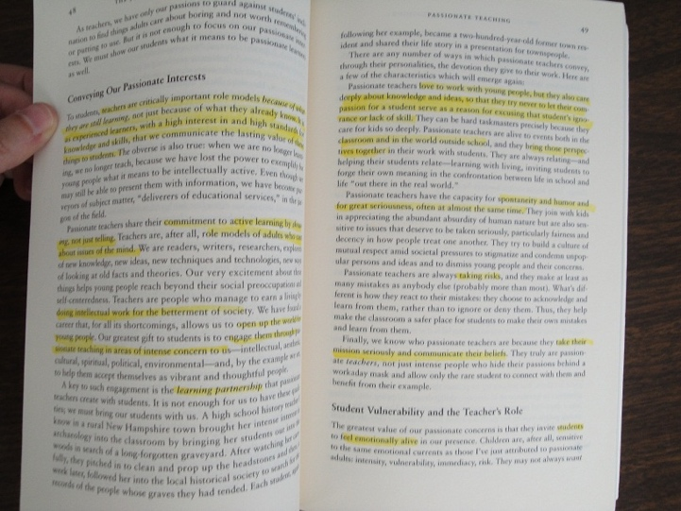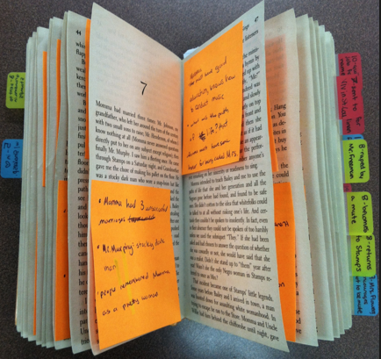

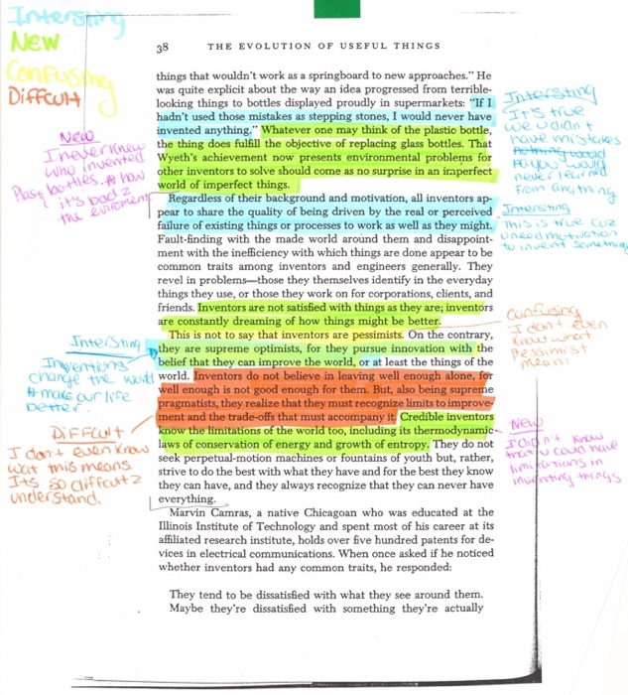
The first image provides an example of a “novice” reading annotation and the remaining images are examples of “excellent” and “competent” work.
Integrative Concept Journal (ICJ)
Transformative learning is not linear or teleological – moving in a straight line from unknown to known – but rather messy, layered, complicated, and interconnected nodes of ideas, stories, experiences, histories that are exposed (made legible and seen) only when examined in relationship to one another. That is what transformative integrative learning is about and that is the purpose of the Integrative Concept Journal – to help students deepen, widen, synthesize and connect their understanding of key course concepts. There are six interlocking ICJ entry options: collaborative synthesis essay, individual synthesis essay, concept glossary, individual concept map, collaborative concept map, critical movie reflection. Together the different components of the ICJ will help students define and understand concepts, identify connections and relationships between ideas, and make meaning out of course material.

By the end of the semester students will complete six ICJ entries.

Option 1-Collaborative Synthesis Essay:
A collaborative essay is a learning activity where two or three students work together to co-create an essay. The steps of collaborative essay writing are as follows:
Step 1:
Student 1 will begin the essay in Google Docs. Undergraduate students will write an approximately 200-word introduction and graduate students approximately 400-words.

Step 2:
Student 1, via google docs, will then “electronically” pass the essay to Student 2.
Step 3:
Student 2 will read Student 1’s introduction, comment on points raised, and then craft a detailed response that reflects on the readings. Student 2 should note Student 1’s essay, reference key ideas from the readings, raise questions, and wrestle with messy concepts.
Step 4:
Student 2 will then pass the essay back to Student 1.
Step 5:
Once each student has written three entries the collaborative essay is complete. [Final undergraduate essay length = approximately 2-3 pages single spaced/ Final graduate essay length = approximately 4-5 pages single spaced.]
Step 6:
Each student should submit the collaborative essay to their ICJ folder. Be sure to note your essay partner(s).

Authentic and critically engaged entries will note the remarks of their writing partner, reflect on them, disagree/agree with them when appropriate, and then expand and add new ideas to the conversation. It is essential that you engage the previous poster while also expanding upon their thoughts and adding your interpretations of the readings.

Option 2-Individual Synthesis Essay:
This semester, we will read, discuss, and engage a significant amount of material, including lectures, videos, documentaries, journal articles, book chapters, and novels. The short integrative essay encourages you to sort, interpret, reflect, synthesize, and make meaning out of the assigned material.

Include the following in the individual synthesis essay:
- Authors’ names
- Article/Chapter title (abbreviated titles are fine)
- Thesis (What is the essential argument an author is making? How does author’s argument illuminate (or challenge) the perspective of another author’s point?
- What are some of the main points articulated in each reading? How do the main points between readings connect?
Undergraduate students should draft an approximately two-page single spaced essay (grads: four-pages) that articulates each author’s essential argument, presents an interpretation that is explicitly linked to assigned readings, meaningfully synthesizes weekly themes, speaks to the interrelatedness of narratives, makes connections across course concepts, and draws relevant conclusions. The essay must be well-crafted and include relevant course concepts/theories and citation of assigned readings required.

Option 3-Concept Glossary:
Select 10 new terms from our lectures and readings to add to the Integrative Concept Journal submission.
Lecture terms:
- Pick five concepts from the lectures and five concepts the readings.
- Lecture concept guidelines:
  - Select a lecture concept and write a definition (at least 5-10 sentences). The definition should be clear and engage historical complexities. Do not simply restate a dictionary or textbook definition – more effort is required.
  - Provide concrete examples (at least 5-10 sentences) of when and how the concept was used in a class lecture. This step encourages students to reflect carefully on the lecture and make meaning out of them. Be sure to explain how the lecture concept connects across multiple weeks. This final step encourages students to make historical/theoretical connections.
- Reading concept guidelines:
  - Draft an original definition (at least 5-10 sentences) of the concept – one based on the readings and not a dictionary. The definition should be clear and engage historical complexities. Do not simply restate a dictionary or textbook definition – more effort is required.
  - You must include a quote from the reading that helps you illuminate the concept. Be sure to correctly cite the author of the quote and note how the highlighted quote expands your understanding of the concept. Your explanation should be at least 5-10 sentences.
- Each glossary entry should be at least 10-20 sentences.

Example 1:
The Dream
- Definition: According to Ta-Nahesi Coates “The Dream” is a socialized myth of American exceptionalism. The Dream represents the illusion that in America, the land of opportunity, anyone can be successful if they work hard. Hard work will allow anyone to succeed and gain entry into the ideal suburban life, nuclear middle-class family. However, Coates argues that “the dream” is an illusion that dismisses the history of how the United States was built on the backs of Black people, on Indigenous genocide. The dream myth also ignores that the resources acquired by whites for their success in building their own dream is dependent on this violence, racial exploitation, and systemic racism.
- Quote: “It is perfect houses with nice lawns. It is Memorial Day cookouts, block associations, and driveways. The Dream is treehouses and the Cub Scouts. The Dream smells like peppermint but tastes like strawberry shortcake. ANs for so long I have wanted to escape into the Dream, to fold my country over my head like a blanket. But this has never been an option because the Dream rests on our backs, the bedding made from our bodies” (Coates 11).
- Context/Example: Our discussions of the Dream in class coincided with the discussions of Ta-Nehisi Coates’s Between the World and Me, and we discussed how in the US “the Dream” is often associated with the Dream of Dr. Martin Luther King Jr. in his speech, but being frozen in time within this dream and being decontextualized from the rest of the critical work he was doing at the time, placing the US in a “post racial” society. But this is far from reality; the Dream Coates speaks of also highly reflects racialized wealth distribution and access to resources in the US, connecting the role of classism and its intersection with racism. The role of the state or nationalism is related here as well, as an American identity becomes built in a middle-class white US, and so the construction of whiteness and the erasure of the construction becomes relevant in this discussion of the Dream. Additionally, a white picket fence and Dream of a nuclear family also speaks to the heteronormativity of this US Dream.

Example 2:
Soul murder
- Definition: Soul murder is the process in a child’s white racial identity development in which instances of emotional and psychological treatment from parents molds the behavior and sense of belonging for the child as being centered in white domination. The white child becomes socialized to these behaviors, and acts in accordance to gain the trust and sense of belonging from parents at the expense of people of color.
- Quote: “As Thankeda explains, in the racial abuse of many non-supremacist white families, no child is beaten or dies. The instances of ‘soul murder’ are ‘objectively seamless events’—a kind of peaceful violence, as Franz Fanon might say— because no overtly violent rupture between child and parent occurs. But something damaging nonetheless could be happening regarding the formation of a white child’s racial and classed identity. That child likely is learning that habits of white domination are required to fully belong to her family” (Shannon 112).
- Cross-week example: I found this term particularly helpful because it seeks to address the process of white racial identity formation in children, something that is often dismissed as whiteness is the norm and thus white children are often not seen as being ‘raced’. This concept of soul murder is also interesting in that it addresses this sense of symbolic violence in the creation and maintenance of white domination, and points to how violence is integral to this creation of a white identity. Soul murder addresses the familial aspect of Harro’s cycle of socialization, especially in regard to the role that consequence of punishment and rewards has in molding behaviors to the status quo of dominant identities.

Option 4-Individual Concept Map:
Students will build one-page concept maps that visually represent individuals, events, and key ideas covered in class. Within a concept map, students should not only depict but concatenate cause-and-effect relationships, theory and derivative theories, and theme and sub-themes. Concept maps should identify at least fifteen (15) essential terms/concepts from the most recent two weeks. Students have the option of designing hand-drawn maps (and insert into a word document) or utilizing a mind mapping tool. Below are a few digital options.

Students have the option of designing hand-drawn maps (and insert into a word document) or utilizing a mind mapping tool. Below are a few digital options.

Coggle is an online mind map that you can use in Chrome. Free version available.
- Mindmeister is a wonderful option because it has a free version and several great templates that makes mapping easy. It also connects with Google Docs via an Add-on (https://support.mindmeister.com/hc/en-us/articles/218402278-MindMeister-for-Google-Docs)

MindMapple is a solid choice and you can cloud share maps via Google Drive. And, it also works for macs.

Text2mindmap is basic but fast. The platform allows you to just type in your thoughts, hit a tab if you want to move on to a new sub-node, and the app does the rest.

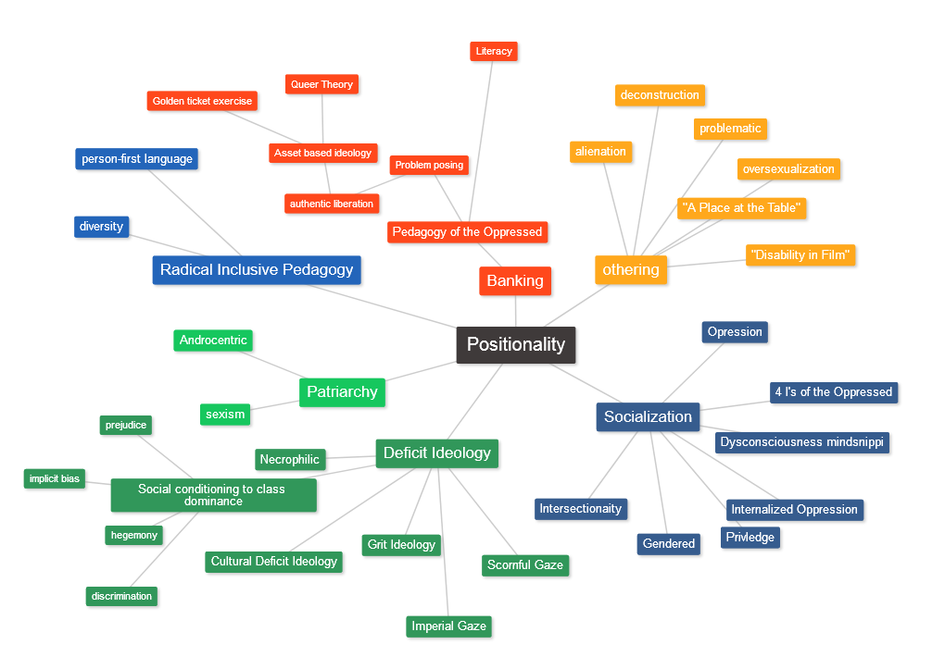

Option 5-Collaborative Concept Map:
Two to three students will collaboratively create a concept, on a whiteboard, that visually represents individuals, events, and key ideas covered in class. Within a concept map, students should depict cause-and-effect relationships, theory and derivative theories, and theme and sub-themes. Collaborative concept maps should identify at least 30 essential terms/concepts from current and previous weeks. Students should include three “in-progress” photos from beginning to end.

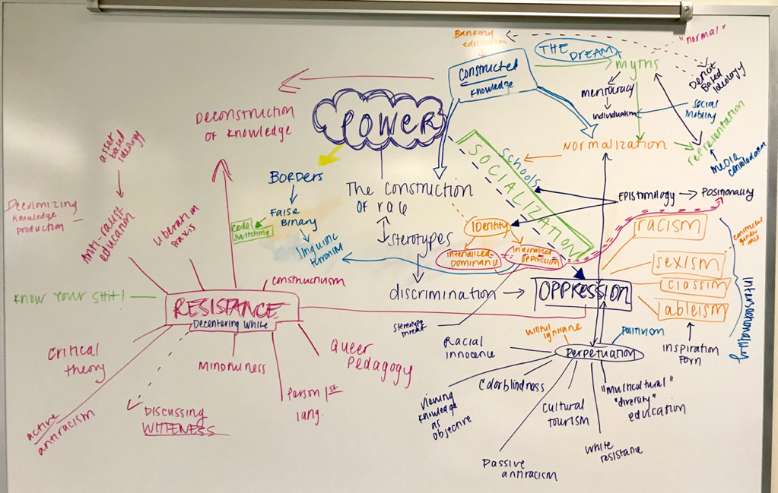

Option 6-Critical Movie Reflection
This semester, students will screen the new movie Hustlers (released September 12). After critically watching the film, draft an essay that explores the movie and its potential connections to our class themes. The movie reflection should demonstrate your ability to sort, interpret, reflect, synthesize, and make meaning out of the movie and assigned material.

Undergraduate students should draft an approximately two-page single spaced essay (grads: four-pages) that articulates each author’s essential argument, presents an interpretation that is explicitly linked to assigned readings, meaningfully synthesizes weekly themes, speaks to the interrelatedness of narratives, makes connections across course concepts, and draws relevant conclusions. The essay must be well-crafted and include relevant course concepts/theories and citation of assigned readings required.

Synthesis Paper:
There will be one final assignment – a synthesis take-home exam. Your essay should draw on assigned course texts and reflect your intellectual development. You do not need to consult any materials outside of the assigned text to successfully complete the final.

Grading Evaluation Structure (4 Credits)
Reading Annotations and Engaged Participation (5 checks) 30%
Integrative Concept Journal (6 submissions) 40%
FFTB Reflection 5%
Synthesis Essay 25%

Required Books
You must purchase and bring to class the following books:
Harriet Jacobs, Incidents in the Life of a Slave Girl (Dover Thrift Edition: 2001)
Ivy Anderson and Devon Angus, Alice: Memoirs of a Barbary Coast Prostitute (Heyday: 2016)

In addition to the required books, we will read a selection of scholarly articles, book chapters, and poems. All of the readings are available as a PDF packet for download via the Blackboard course site. You MUST download and print the PDF reading packet.

PDF Packet Order Instructions
To order a copy of the PDF packet visit https://www.gmuprinthub.com and complete the following steps:
- Click on Booklets (at bottom of page).
- Click on Bound Booklets.
- Select the following options:
  - How many pages in the document? = 335
  - How many pages ae black & white? = 335
  - Print single or double-sided = 2
  - Inside Paper Stock = 20lb White Standard
  - Cover Paper Stock = Clear Front & Black Back
  - Binding choices = Plastic coil
  - Turnaround time = select 2 days
- Total: $31.54

ABREVIATED DAY-BY-DAY SCHEDULE
FALL 2019
Our syllabus is a living document and there will be changes throughout the semester. Any updates or revisions will be announced in class and made available via Blackboard.
DATE | READING ASSIGNMENT  (TO BE COMPLETED BEFORE CLASS) | DUE DATES
WK 1  8/28 | Good Wives and Nasty Wenches: An Introduction  Introduce syllabus and course expectations. | Order PDF Binder NOW
WK 2  9/4 | Sexual Regulation and the Social Construction of Race
WK 3  9/11 | “I didn’t want him, but I couldn’t do nothin’” - The Interstitial World of Enslaved Black Women | Annotation check #1
WK 4  9/18 | White Women and Sexualized Black Male Bodies | ICJ #1 due  by midnight
WK 5  9/25 | Racialized Pleasure Politics in the Atlantic World | Annotation Check #2
WK 6  10/2 | Placage, White Male Privilege, and the Quadroon Body in Louisiana | ICJ #3 due  by midnight
WK 7  10/9 | Red Light Ladies: Sex Workers in the Early American West | Annotation Check #3
10/10 | FFTB: Gender, Power, & Violence in the #MeToo Era  1:30-2:45PM
10/11 | FFTB: Chimamanda Ngozi Adichie, We Should All Be Feminists  12:30-1:45PM
WK 8  10/16 | Reading Day-Class will NOT meet. | See you next week.
WK 9  10/23 | A Voice from the Underworld: Making Space for Counternarratives | ICJ #4 due by midnight
WK 10  10/30 | White Slavery: Racism and the Policing of Sexuality | Annotation Check #4
WK 11  11/6 | P*ssy Power: Whore, Feminist, and Activist | ICJ #5 due  by midnight
WK 12  11/13 | Making it Rain: Sex Worker Power, Agency, and Survival | Annotation Check #5
WK 13  11/20 | What’s Wrong with Being a Slut: Whores, THOTS, and Side Pieces | ICJ #6 due  by midnight
WK 14  11/28 | Fall Holiday Break  CLASS WILL NOT MEET
WK 15  12/4 | Pulling it all together
 | Final Exam Due on 12/12 by 4:30PM

