PSYC 379-DL1 – Applied Cross-Cultural Psychology

This syllabus may change.
This syllabus has been updated as of 8/14/2019

Instructor: Mayra Parada E-mail: mparada2@gmu.edu
Office: David King Hall 1028
Office Hours: Wednesdays 11-12, or by appointment

Textbook

1. Matsumoto, D., & Juang, L. (2017). Culture and psychology (6th ed.). New York, NY: Cengage Learning.

2. Selected articles posted on Blackboard

Course Overview
Welcome to Applied Cross-Cultural Psychology! This course provides an overview of the theoretical and empirical developments currently defining the field of cross-cultural psychology. The course will emphasize empirical approaches to cross-cultural study and explain the importance of culture in human cognition, perception, intelligence, emotion, socialization, and mental health. Students will gain an understanding of explicit and implicit cultural messages, and how an individual's views about themselves, others, and the world around them can be shaped by these messages. The course is primarily conducted online, with several experiential exercises assigned throughout the semester. Course objectives include increasing students’ understanding of how culture influences mental processes and behavior, and enhancing students’ knowledge about cross-cultural research.
Course Goals
As the course instructor, I have several goals for each student to work toward during this semester:
1) An awareness of the hidden and obvious gender biases in the study of human behavior and an appreciation of the complexity of the research on gender issues
2) Clarification of the nature and development of gender differences and gender roles
3) Development of critical thinking and skill in evaluating gender in the media
4) Development of an intellectual tolerance and respect for others' viewpoints
5) Development of self-understanding and empowerment, appreciating that we need not be constrained by traditional gender roles and stereotypes

Course Format

This course will be held entirely online. Information will be presented in PowerPoint lectures, articles and assigned textbook readings. Students are responsible for understanding all of the information presented in articles, and in their textbook and these PowerPoint lectures. For each of the chapters, students must complete an online chapter quiz (see below for more information regarding these quizzes) as well as a discussion post and discussion response (see below for more information regarding these discussion based assignments.) These assignments are designed to ensure that students both have an understanding of the core course content as well as an ability to participate in classroom discussions in order to enrich their overall understanding of cross-cultural issues. These assignments will be due at specific dates throughout the semester (see Calendar at bottom of syllabus for a list of due dates – due at 11:59 every Monday). Throughout the semester, students will complete a midterm and final exam to ensure a complete and thorough understanding of all course materials. Although each of the quizzes, assignments, article critique, and exams for this course have specific final due dates, students are allowed to complete all of these in advance. Thus, the pace of this course is somewhat flexible.

Lectures

As stated above, this course will deliver content PowerPoint slides. These lectures will be posted on Blackboard at the beginning of the semester. PowerPoints will include key terminology, important concepts, and detailed information. Most of this information will be provided in text, but some information may also be presented through voice recordings. Students are responsible for understanding all of the audio and visual-based information presented in these slides.

Students should use the textbook to supplement their knowledge and understanding of the information presented in these slides. If students are unsure about a specific concept, they should first consult their textbook for more information regarding this topic. If they are still unsure about a topic, they may email the instructor.

Chapter Quizzes

After reviewing the materials for each chapter, students must complete an online chapter quiz, located on Blackboard. These quizzes will be primarily based on materials from the PowerPoint slides. Students will only have one opportunity to complete this quiz, and once they submit their answers, their grades will be posted automatically to Blackboard. These quizzes will be multiple-choice, and students will be given a limited amount of time to complete these quizzes to ensure that they do not cheat. You may access your notes, but each quiz has a time limit, so use your time wisely!

Students will not be able to complete a quiz after midnight of the assigned due date under any circumstance! Students who fail to complete a chapter quiz in the appropriate amount of time will automatically receive a grade of 0%. As stated previously, students are encouraged to complete the chapter quizzes well before the due date to ensure that they do not miss a quiz. Again, there will be NO exceptions for late work.

These chapter quizzes will account for 20% of a student’s overall final grade in the course.

Discussion Posts

For each chapter, students must also post and respond to a post on the Blackboard Discussion board. Students must post a unique, interesting and relevant video, link, popular press article, scholarly article, or a current event article related to a topic presented within that chapter that the student found interesting. Along with their post, students must provide an APA style citation of where the information was found, a summary of their post, an explanation of why the post is interesting/relevant to the given chapter, and/or any other comments or ideas that the student has regarding their posting. These posts should be at least three full sentences (not including the citation). The goal of these posts is to spur discussion among classmates, so they should be as thought-provoking and engaging as possible in order to encourage other students to read and respond. I encourage healthy discussions and debates through these discussion threads.

Students must also read and respond to a discussion post of at least one other classmate. These responses should include overall thoughts/ideas spurred by the post, other reasons why the post was interesting, other ways that the post was relevant to topics outlined within the course, aspects of the post that the student may agree/disagree with, and/or any other observations that the student would like to make about the post. These responses should also be at least three sentences, and please remember to be respectful and polite regarding other students’ opinions when posting these responses.

For some of the weeks, you will respond to an article that I will post. For your discussion post for the corresponding week, please write your reaction of the article, how it relates to the content in the chapter, and how it is relevant to research in psychology. You must also respond to another student’s post.

Empirical Article Summary and Critique.

Students will select an empirical article/research study with human subjects (not a review) of their choice from the Journal of Cross-Cultural Psychology and write a 3-5 page (APA style - double-spaced, Times New Roman font, size 12) summary and critique of the article. The brief paper should start with a summary of what the researchers did, with whom, why it is interesting/important, and what the authors found. Then you must connect the article explicitly to at least three (3) concepts we have discussed in the course (both in terms of methodology/research methods and content), plus mention at least two (2) methodological strengths and two (2) methodological problems/criticisms that you perceive of the study. No late submissions will be accepted.

Midterm and Final Exam

There will be two exams for this course, a midterm exam and a final exam. Each exam will cover chapters that we have already gone over in the subsequent weeks. The questions will not be the same as those encountered on the chapter quizzes! Student should spend ample time studying all of the materials from each of the chapters before embarking on this final exam. Students will only have one opportunity to complete this exam, and once they submit their answers, their grades will be posted automatically to Blackboard. To ensure that students do not cheat, students will be given a limited amount of time to complete this exam and each student will be presented with a different set of questions.

Students must complete this final exam by midnight on the due date assigned to receive credit for this exam. Students who fail to complete this exam by the appropriate time will automatically receive a grade of 0%. There will be NO exceptions. This exam will account for 20% of a student’s overall grade in the course.

Grade Breakdown

Exams 40% (20% each)
Article critique 20%
Discussion Posts 20%
Chapter Quizzes 20%
Total 100%
Grading Scale:
A+ = 97-100% B+ = 87-89% C+ = 77-79% D = 60-69%
A = 93-96% B = 83-86% C = 73-76% F = <60%
A- = 90-92% B- = 80-82% C- = 70-72%

Additional Information

Email Policies
For questions regarding course content, please email the instructor – mparada2@gmu.edu
Please make sure you re-read the syllabus before asking questions about the policies, procedures, or format of the course.
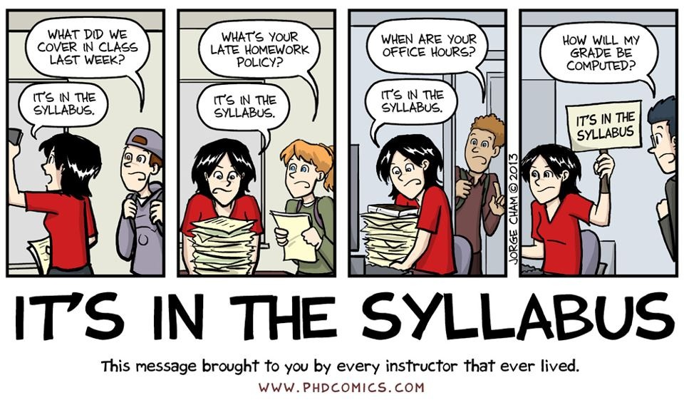
Official Communications via GMU E-mail: Mason uses electronic mail to provide official information to students. Examples include communications from course instructors; notices form the library, notices about academic standing, financial aid information, class materials, assignments, questions, and instructor feedback. Students are responsible for the content of university communication sent to their mason e-mail account, and are required to activate that account and check it regularly. I can only respond to gmu.edu email addresses, so please only use your Mason email in correspondence with me.

Blackboard: I will post notes, resources, grades, and announcements on Blackboard. You should frequently check Blackboard because you will be responsible for the material posted. Additionally, all assignments will be turned in through Blackboard. To use Blackboard you will need to go to https://mymasonportal.gmu.edu.

Honor Code: Coursework is expected to be the student’s own original work. Students may use books, notes, and other sources to prepare assignments. Under no circumstances are students to collectively write papers with another student, turn in work previously submitted, reference notes or class materials during tests, or use material from other sources (textbook, websites, journal articles etc.) without proper citation (APA style). This will be considered plagiarism and will not be tolerated. All George Mason University students have agreed to abide by the letter and the spirit of the Honor Code. You can find a copy of the Honor Code at academicintegrity.gmu.edu. All violations of the Honor Code will be reported to the Honor Committee for review. I reserve the right to enter a failing grade for any student found guilty of an honor code violation.

Disability Accommodations: If you have a documented learning disability or other condition that may affect academic performance you should: 1) make sure this documentation is on file with Office of Disability Services (SUB I, Rm. 4205; 993-2474; http://ods.gmu.edu) to determine the accommodations you need; and 2) talk with me to discuss your accommodation needs.

Course Schedule
Date | Content | What’s due on Sunday?
8/26/19 | Ch 1: An Introduction to Culture and Psychology | Discussion Post: Introduction of yourself
9/2/19 | Ch 2: Cross-Cultural Research Methods | Quiz 1  Discussion Post
9/9/19 | Ch 3: Enculturation | Quiz 2  Discussion Post
9/16/19 | Ch 4: Culture and Developmental Processes | Quiz 3  Discussion Post
9/23/19 | Ch 5: Culture, Self, and Identity | Quiz 4  Discussion Post
9/30/19 | Ch 6: Culture and Personality | Quiz 5  Discussion Post
10/6/2019 | Ch 7: Culture and Gender | Quiz 6  Discussion Post:
10/13/19 | Midterm Exam
10/21/19 | Ch 8: Culture and Cognition | Quiz 7  Discussion Post
10/28/19 | Ch 9: Culture and Emotion | Quiz 8  Discussion Post
11/4/19 | Ch 10: Culture, Language, and Communication | Quiz 9  Discussion Post:
11/11/19 | Ch 11: Culture and Health | Quiz 9  Discussion Post
11/18/19 | Ch 12: Culture and Psychological Disorders | Article Critique Due
11/25/19 | Ch 13: Culture and Treatment for Psychological Disorders | Quiz 10  Discussion Post:
12/2/19 | Ch 14: Culture and Social Behavior | Quiz 11  Discussion Post
12/9/19 | Final Exam
*This syllabus is subject to change. Please listen to lectures and monitor the course website
regularly to be informed of any changes made to the course.*

Last Day to Add: January 30
Last Day to Drop: February 24

