CRITICAL RACE STUDIES
Monday 4:30 pm - 7:10 pm
Fall 2019

Welcome!
I am looking forward to being your instructor this semester. In order for this to be a great class for both of us, I need you to understand the importance of keeping me informed of your needs and challenges.

Instructor communication policy: I am available to hear your concerns, to discuss course topics, and to provide strategies for your academic success. Feel free to come by my office anytime. If my door is open, just stop on in to chat, I would love to see you. Or, if you would like to schedule an appointment, please let me know and we can work out a time to meet (Starbucks is great), a phone call via Google Voice, or a live ZOOM conference call. If you would like to schedule a Google Voice or ZOOM meeting with me, send me an email with three date/time options that you are available.

I will respond to your email inquiries within 24 hours during the week (Monday through Friday). I do my best to be responsive on the weekends, but I am human and need a bit of rest and relaxation with my family. Let’s make this a great semester!

Instructor: Dr. Wendi Manuel-Scott
Office Location: School of Integrative Studies, 407 Enterprise Hall
E-mail: wmanuels@gmu.edu | SIS Web: http://integrative.gmu.edu
Call or Text me via Google Voice: (703) 249-9094
Office hours by appointment.

“[History] is not the past. History is the present. We carry our history with us. To think otherwise is criminal.”
James Baldwin

"I tell my students, 'When you get these jobs that you have been so brilliantly trained for, just remember that your real job is that if you are free, you need to free somebody else. If you have some power, then your job is to empower somebody else.'"
Toni Morrison

“Nobody’s going to save you. No one’s going to cut you down, cut the thorns thick around you. No one’s going to storm the castle walls nor kiss awake your birth, climb down your hair, nor mount you onto the white steed. There is no one who will feed the yearning. Face it. You will have to do, do it yourself.”
Gloria Anzaldua

Course Description
This course engages students in a sociohistorical, sociopolitical, and socioeconomic examination of the forms and impacts of racism, as well as movements for racial justice, in the United States with an emphasis on a critical race studies framework. Using an integrative and interdisciplinary approach, the course draws on intersecting and divergent knowledge, both from a variety of scholarly disciplines and from the oral and written histories of racial justice activists and movements. Students will draw on the most contemporary theoretical frameworks including critical race theory and intersectionality theory in order to examine the structural roots of racism and the implicit and explicit ways in which racism manifests today.

Student Learning Outcomes
Students who take this course will:
- Develop and be able to articulate a complex understanding of racism and its relationship with other forms of structural injustice in the U.S. through a critical race theory lens;
- Apply critical race theory and other forms of knowledge about racism to reach a deeper understanding of how structural racism impacts the lives of individuals and communities;
- Strengthen their knowledge about the history of racial justice movements; and
- Apply theoretical and practical understandings of racism and racial justice to contemporary manifestations of racism in order to help create a more racially just society.
These goals will be achieved through
- Creating detailed reading annotations and an interactive concept journal.
- Active participation in classroom discussions.
- Full engagement in experiential learning project.
- Final synthesis essay.
This learning community stresses the following competencies:
- Communication: written and verbal
- Critical thinking: analysis of written and visual texts
- Group interaction: collaborative in-class work and classroom discussions

Commitment to Creating an Inclusive Learning Environment

Given the sensitive and challenging nature of the course themes, it is imperative that we create an atmosphere of respect and safety in the classroom. To this end, I am committed to fostering an environment of deep understanding and mutual responsibility. And while I believe that racist, sexist, homophobic, and overall offensive language does not contribute to creating a safe space for learning, few of us have had enough time to recognize our implicit biases fully. We must, therefore, acknowledge that we are all works in progress. Regardless of our race, gender, sexual orientation, cultural background, or ethnicity, we are at various points along a lifelong anti-racist (anti-sexist) journey. Getting better – and doing better – requires daily commitment.

In this course, students are encouraged to look for opportunities to create community, understanding, and compassion. To assist in creating a positive inclusive learning community below are some useful practices:
- Assume your classmates’ viewpoints are important and listen to them – without judgement.
- Begin comments with a sincere affirmation of colleagues’ point. For example, “While Hassam made a good point, I argue that. . .” or “I liked how Manuela noticed that . . .”
- Avoid generalizations about others (including gender identities, racial/ethnic groups, class status etc).
- Use “I” rather than “you” language; you can only speak for yourself and your experiences.
- Ask questions when you don’t understand.
- Be aware of your assumptions and avoid essentialist comments (ie. statements that assume certain experiences are universal).
- Be willing to be intellectually uncomfortable.
- Support your position with reading annotations, class notes, and course texts. Avoid personal revelations and anecdotes unless they are relevant to course topics.

The School of Integrative Studies, an intentionally inclusive community, promotes and maintains an equitable and just work and learning environment. We welcome and value individuals and their differences including race, economic status, gender expression and identity, sex, sexual orientation, ethnicity, national origin, first language, religion, age and disability. We value our diverse student body and desire to increase the diversity of our faculty and staff.
- We commit to supporting students, faculty and staff who have been the victims of bias and discrimination.
- We promote continuous learning and improvement to create an environment that values diverse points of view and life experiences.
- We believe that faculty, staff and students play a role in creating an environment that engages diverse points of view.
- We believe that by fostering their willingness to hear and learn from a variety of sources and viewpoints, our students will gain competence in communication, critical thinking and global understanding, aware of their biases and how they affect their interactions with others and the world.

Technology Guidelines
Blackboard
You are encouraged to your email and our Blackboard course site several times a week, as I will use both email and Blackboard to communicate with you between classes. All assignments should be turned in via Blackboard unless other instructions are provided. If you require assistance with Blackboard access, please contact the Mason IT Unit: https://itservices.gmu.edu/.

Recording:
You are not allowed to record classroom discussions or lectures.
Email
Electronic mail is a valuable tool. I will, from time to time, send emails to the class, and I am happy to respond to your email messages provided you bear in mind the following points. In academic and professional settings, all emails should have a descriptive subject line (“Question about Critical Race Studies assignment”), begin with a respectful salutation (“Prof. Manuel-Scott”), and conform to standard English with proper punctuation and capitalization. Do not use instant message abbreviations. All correspondence should take place via your Mason email account. If you have not activated you Mason email account, go to https://mail.gmu.edu/, and select “activate account.”

Technology
This class has a “no-screens” policy. I do not allow electronic devices (including laptops, smartphones, tablets, etc.) in my class. You should not attempt to respond to emails, tweet, group chat, Instagram post or watch the latest Beyonce video during our class session. These activities negatively impact learning. I believe that during class, your attention should not be divided between classroom dialogue/lecture and electronic devices. Therefore, out of respect to your colleagues and me, texting is never allowed in class. Your participation grade will be significantly impaired if I see you distracted by an electronic device.

University Policies

Honor Code, Plagiarism, Collaboration
It is expected that students adhere to the George Mason University Honor Code as it relates to integrity regarding coursework and grades. When you enrolled in this course you agreed to abide by the university's Honor Code and it reads as follows:

To promote a stronger sense of mutual responsibility, respect, trust, and fairness among all members of the George Mason University Community and with the desire for greater academic and personal achievement, we, the student members of the university community, have set for this Honor Code: Student Members of the George Mason University community pledge not to cheat, plagiarize, steal, or lie in matters related to academic work.

The Honor Code does not preclude collaborative work, such as informal discussions and studying in communities. Nor does it preclude assigned group work. The Honor Code does require that the work that a student, as an individual, turns in is ultimately the product of his/her own individual synthesis or integration of ideas, and that the work a group turns in is ultimately the product of the group's collective ideas. If you are uncertain of the line between collaboration and cheating, you should see me before turning in an assignment.

You must always cite your sources - if you do not, it is plagiarism. Plagiarism means taking someone else's ideas or words and presenting them as your own without proper attribution of the source. You must correctly and consistently use APA, Chicago, or MLA citation style. This includes copying materials directly from the Internet. If you feel uncertain about any aspect of the Honor Code, you should discuss your concerns with me proactively (i.e., before turning in a piece of work).

More information about the Honor Code, including definitions of cheating, lying, and plagiarism, can be found at the Office of Academic Integrity website at https://oai.gmu.edu

Please remember that no grade is important enough to justify academic misconduct. Should you experience extreme academic anxiety there are resources on campus to assist you during stressful moments. Please reach out to me or one of the University office offering writing assistance, study skills, or counseling.

Creating an Inclusive Learning Environment
Gender Inclusive Language
Language is gender-inclusive and non-sexist when we use words that affirm and respect how people describe, express, and experience their gender. Gender-inclusive/non-sexist language acknowledges people of any gender (for example, first year student versus freshman, chair versus chairman, humankind versus mankind, etc.). It also affirms non-binary gender identifications and recognizes the difference between biological sex and gender expression. Students may share their pronouns and names, and these gender identities and gender expressions should be honored.

Sexual Misconduct and Interpersonal Violence
George Mason University is committed to providing a learning, living and working environment that is free from discrimination, and we are committed to a campus that is free of sexual misconduct and other acts of interpersonal violence in order to promote community well-being and student success. We encourage students who believe that they have been sexually harassed, assaulted or subjected to sexual misconduct to seek assistance and support. University Policy 1202 Sexual Harassment and Misconduct (http://universitypolicy.gmu.edu/policies/sexual-harassment-policy/) speaks to the specifics of our process, our resources, and the options available to you.

Confidential student resources are available on campus at the Student Support and Advocacy Center (http://ssac.gmu.edu/), Counseling and Psychological Services (http://caps.gmu.edu/), and Student Health Services (http://shs.gmu.edu/).

All other members of the University community (including faculty, except those noted above) are not considered confidential resources and are required to report incidents of sexual misconduct to the University Title IX Coordinator. For a full list of resources, support opportunities, and reporting options, contact Dr. Jennifer Hammat, Title IX Coordinator, at http://diversity.gmu.edu/title-ix, at 703-993-8730, or in the Compliance, Diversity, and Ethics office in the Aquia Building, Suite 373.

Disabilities and Academic Accommodations
I am very supportive of students with different learning abilities. However, I cannot help you unless I know about it in advance. If you have a documented learning disability or other condition that may affect academic performance you should: 1) make sure this documentation is on file with Disability Services (SUB I, Rm. 4205; 993-2474; http://ods.gmu.edu) to determine the accommodations you need; and 2) talk with me to discuss your accommodation needs.

If you have contacted the Office of Disability Services and are waiting to hear from a counselor, please tell me. If you qualify for accommodation, the ODS staff will give you a form detailing appropriate accommodations for your instructor. In addition to providing me with the appropriate form, please take the initiative to discuss required accommodations at the beginning of the semester and as needed during the term.

Statement of Collegiate Compassion
I believe we learn best when we can show up as whole and healthy people. To learn effectively we need to have basic security: a roof over our head, a safe place to sleep, a stable place to live, and enough food to eat. If you are struggling to meet any of these basic needs please talk to me, visit our campus food pantry (https://ssac.gmu.edu/patriot-pantry/), or reach out to other Mason resources. Remember, asking for assistance and advocating for yourself is an important part of your collegiate experience. I am here to help, and YOU are not alone.
Religious and Cultural Observances
Some course assignments may be in close proximity to religious or cultural observances. If an assignment creates a conflict, please talk to me in advance so we can make appropriate arrangements.

Lesbian, Gay, Bisexual, Transgender, Queer, & Questioning Resources
SUB 1, Suite 2200; 993-2702; http://lgbtq.gmu.edu/

Office of Diversity, Inclusion, and Multicultural Education (ODIME)
SUB 1, Suite 2400; 993-2700; http://odime.gmu.edu

Star-Multimedia Computer Lab
Johnson Center, Rm 229; 993-8990; http://doit.gmu.edu/studentSection.asp?page=multimedia_lab

Women and Gender Studies Center
Johnson Center, Rm 240K; 993-2896; http://wmst.gmu.edu/center

Writing Center
The services of the Writing Center are available by appointment, on-line and, occasionally, on a walk-in basis. Occasionally, I will refer students to the Writing Center and I take these referrals very seriously. If I refer you to the Writing Center, I hope you will take advantage of their services. There are multiple locations on Fairfax, Prince William, and Arlington campuses (see website for info about locations and numbers); http://writingcenter.gmu.edu/

Attendance and Engaged Participation
I expect you to be in class and will take daily attendance. You can’t participate if you’re not present, so it is to your benefit to be in class and on time. You should also note that I construe “present” to mean both physical and active mental engagement. I also expect students to complete all of the assigned readings before class. It is also to your advantage to listen closely to lecture material and to take notes during lectures and films.

I place a high value on promptness. I feel very strongly that there are very few excuses for late arrivals. You are expected to arrive on-time and leave when class is over. Please avoid planning appointments which overlap with the class time. Repeat offenses will negatively impact your grade.

Your participatory engagement will be considered “adequate” (C-level) if you are paying attention, adding a comment now and then, and following instructions for in-class activities. “Good” (B-level) engaged participation includes active prepared interaction with me and your colleagues on a consistent basis; “Excellent” (A- level) engagement includes all of the B-level expectations plus use of appropriate course terminology and excellent use of assigned text, frequently calling attention to specific passages relevant to class discussions.

My expectation is that you will be actively engaged in the learning process by contributing to our class discussions, and consistently attending class. If you are absent, do not ask me (in person or via email) if you “missed anything important?” or “what did I miss?”

“Shit Happens” Policy
Due dates for every assignment are provided on the course schedule. However, I know that sometimes “shit happens” and life often takes an unexpected turn. When this occurs, you have access to two “shit happens” days. These days (used together as 48hrs or separately as 24hrs + 24hrs) allow you to submit an assignment (or two separate assignments) late without penalty. You can use these days for ANY ICJ or EL assignment. You do not need to explain to me why you need the extension: simply place “shit happens” on the top of the late assignment submitted to Blackboard and note how many of your “shit happens” days you are using. Once you’ve exhausted your “shit happens” days, the point deductions will occur for any assignment submitted after the deadline.

Classroom Ethics and Etiquette
- Turn off. Tune in. Before each class turn off your cellphone and other electronic devices. Remember I have an absolute ban on electronic communication including cell phones, computers and any other equipment without express permission, except when we are using technology as a class.
- Sleeping or otherwise “tuning out” is not acceptable; class requires engagement from all members of our academic community. Falling asleep will result in a zero-participation score for the day.
- Bring your “A” game. ALWAYS bring materials to class. Failure to do so will result in a zero-participation score for the day.
- Take great notes. I consider note taking essential to the learning process. It is always to your intellectual advantage to listen closely (and critically) to lecture material and to take notes during lectures and class discussions.
- I must see your books, articles, and notebooks open on your desks during class. You cannot possibly do well in this class without demonstrating (through journaling notes, questions, etc. in your books and PDF reading packet) that you are reading the texts.

Course Warning:
Please note that this course is reading intensive. A significant amount of the workload for this course will be in reading all of the assignments in addition to maintaining detailed annotations and completing ICJ entries. Some students may find the lengthy reading assignments a major challenge; therefore, plan accordingly.

Reading Annotation Guidelines: Becoming an Active Reader
All of us—students and instructor—will be actively learning in this course. We will teach each other and learn from each other as we co-create our learning community. The practice of co-creation requires full participation and I am interested in being in a class in which everyone is prepared, curious, and engaged.
To facilitate everyone being fully engaged, the PDF packet and books are required at every class meeting. In addition, to demonstrate that you are actively reading, you must annotate ALL required texts (articles, chapters, and books). I believe annotations help students understand the texts on a deeper level and serve as the analytic foundation for our fishbowl dialogues, class discussions, media analysis, and final projects.
In order to earn full credit, you must read assigned texts before class and have detailed annotations. This means picking of a pen and using it while reading. Highlighting alone is not enough. EVERY PAGE must include a COMMENT, QUESTION, OR NOTATION to earn full credit.
Note: I will NOT check annotations that are not printed and bound.
Active Reader Annotation Requirements:
- Note the main argument/thesis - in your own words – in the margins or on a sticky note.
- In the margins or on a sticky, jot down the main ideas key of paragraphs or sections to help you recall information quickly.
- At the end of a section (or page), summarize the main idea and note how the reading connects to course themes.
- Write key terms and/or concepts on a page and write the definition in the margins or on a sticky.
- Highlight passages and note why the passage engaged you. Or, raised questions for you.
- Highlight passages and/or concepts that connect with other readings.
- Write down three or four questions that will help you participate in class discussion.

Your annotations will be checked before, during or after class meetings and all students should be prepared to participate in discussions using reading annotations. There are NO makeups (without medical documentation) if you miss an annotation check.

Annotations Grading Point System:
- Check Plus = Excellent work demonstrates rigor, consistency, and a serious commitment to annotating assigned texts (with specificity and detail). Significant notation required to earn a check plus.
- Check = Competent work demonstrates adequate but inconsistent and/or incomplete annotations across pages and multiple readings.
- Check minus = Novice work fulfills few of the requirements and shows limited effort. Often includes highlighted pages or underlined sections with minimal annotating.

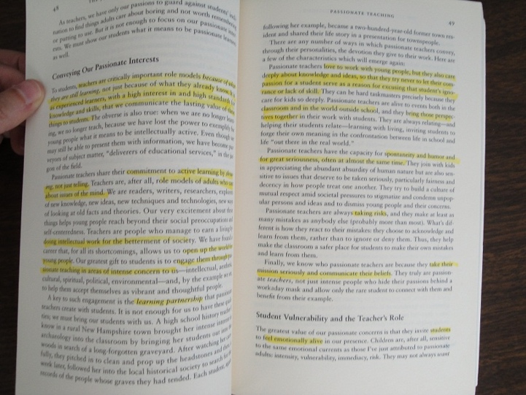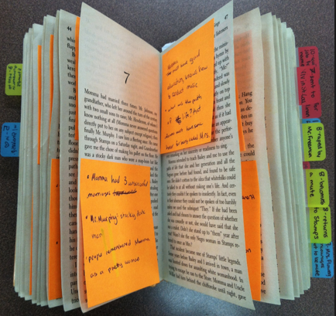
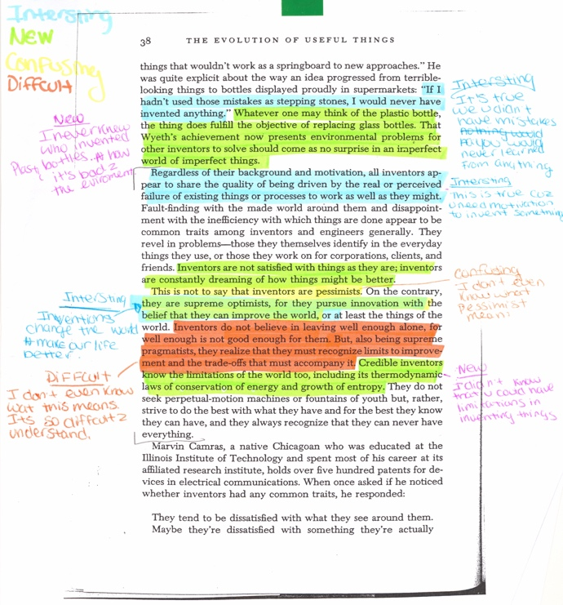
The first image provides an example of a “novice” reading annotation and the remaining images are examples of “excellent” and “competent” work.
Integrative Concept Journal (ICJ)
Transformative learning is not linear or teleological – moving in a straight line from unknown to known – but rather messy, layered, complicated, and interconnected nodes of ideas, stories, experiences, histories that are exposed (made legible and seen) only when examined in relationship to one another. That is what transformative integrative learning is about and that is the purpose of the Integrative Concept Journal – to help students deepen, widen, synthesize and connect their understanding of key course concepts. There are five interlocking ICJ entry options: collaborative synthesis essay, individual synthesis essay, concept glossary, individual concept map, and collaborative concept map. Together the different components of the ICJ will help students define and understand concepts, identify connections and relationships between ideas, and make meaning out of course material.

Students should identify classmates and organize schedules accordingly so that they are able to successfully coordinate the completion of the collaborative synthesis essay and the collaborative concept map.

Option 1-Collaborative Synthesis Essay:
A collaborative essay is a learning activity where two or three students work together to co-create an essay. The steps of collaborative essay writing are as follows:
Step 1:
Student 1 will begin the essay in Google Docs. Undergraduate students will write an approximately 200-word introduction and graduate students approximately 400-words.
Step 2:
Student 1, via google docs, will then “electronically” pass the essay to Student 2.
Step 3:
Student 2 will read Student 1’s introduction, comment on points raised, and then craft a detailed response that reflects on the readings. Student 2 should note Student 1’s essay, reference key ideas from the readings, raise questions, and wrestle with messy concepts.
Step 4:
Student 2 will then pass the essay back to Student 1.
Step 5:
Once each student has written three entries the collaborative essay is complete. [Final undergraduate essay length = approximately 2-3 pages single spaced/ Final graduate essay length = approximately 4-5 pages single spaced.]
Step 6:
Each student should submit the collaborative essay to their ICJ folder. Be sure to note your essay partner(s).

Authentic and critically engaged entries will note the remarks of their writing partner, reflect on them, disagree/agree with them when appropriate, and expand and add new ideas to the conversation. It is essential that you engage the previous poster while also expanding upon their thoughts and adding your interpretations of the readings.

Option 2-Individual Synthesis Essay:
This semester, we will read, discuss, and engage a significant amount of material, including lectures, videos, documentaries, journal articles, book chapters, and novels. The short integrative essay encourages you to sort, interpret, reflect, synthesize, and make meaning out of the assigned material.

Include the following in the individual synthesis essay:
- Authors’ names
- Article/Chapter title (abbreviated titles are fine)
- Thesis (What is the essential argument an author is making? How does author’s argument illuminate (or challenge) the perspective of another author’s point?
- What are some of the main points articulated in each reading? How do the main points between readings connect?
Undergraduate students should draft an approximately two-page single spaced essay (grads: four-pages) that articulates each author’s essential argument, presents an interpretation that is explicitly linked to assigned readings, meaningfully synthesizes weekly themes, speaks to the interrelatedness of narratives, makes connections across course concepts, and draws relevant conclusions. The essay must be well-crafted and include relevant course concepts/theories and citation of assigned readings required.

Option 3-Concept Glossary:
Select 10 new terms from our lectures and readings to add to the Integrative Concept Journal submission.
Lecture terms:
- Pick five concepts from the lectures and five concepts the readings.
- Lecture concept guidelines:
  - Select a lecture concept and write a definition (at least 5-10 sentences). The definition should be clear and engage historical complexities. Do not simply restate a dictionary or textbook definition – more effort is required.
  - Provide concrete examples (at least 5-10 sentences) of when and how the concept was used in a class lecture. This step encourages students to reflect carefully on the lecture and make meaning out of them. Be sure to explain how the lecture concept connects across multiple weeks. This final step allows students to make historical/theoretical connections.
- Reading concept guidelines:
  - Draft an original definition (at least 5-10 sentences) of the concept – one based on the readings and not a dictionary. The definition should be clear and engage historical complexities. Do not simply restate a dictionary or textbook definition – more effort is required.
  - You must include a quote from the reading that helps you illuminate the concept. Be sure to correctly cite the author of the quote and note how the highlighted quote expands your understanding of the concept. Your explanation should be at least 5-10 sentences.
- Each glossary entry should be approximately 10-15 sentences.

Example 1:
The Dream
- Definition: According to Ta-Nahesi Coates “The Dream” is a socialized myth of American exceptionalism. The Dream represents the illusion that in America, the land of opportunity, anyone can be successful if they work hard. Hard work will allow anyone to succeed and gain entry into the ideal suburban life, nuclear middle-class family. However, Coates argues that “the dream” is an illusion that dismisses the history of how the United States was built on the backs of Black people, on Indigenous genocide. The dream myth also ignores that the resources acquired by whites for their success in building their own dream is dependent on this violence, racial exploitation, and systemic racism.
- Quote: “It is perfect houses with nice lawns. It is Memorial Day cookouts, block associations, and driveways. The Dream is treehouses and the Cub Scouts. The Dream smells like peppermint but tastes like strawberry shortcake. ANs for so long I have wanted to escape into the Dream, to fold my country over my head like a blanket. But this has never been an option because the Dream rests on our backs, the bedding made from our bodies” (Coates 11).
- Context/Example: Our discussions of the Dream in class coincided with the discussions of Ta-Nehisi Coates’s Between the World and Me, and we discussed how in the US “the Dream” is often associated with the Dream of Dr. Martin Luther King Jr. in his speech, but being frozen in time within this dream and being decontextualized from the rest of the critical work he was doing at the time, placing the US in a “post racial” society. But this is far from reality; the Dream Coates speaks of also highly reflects racialized wealth distribution and access to resources in the US, connecting the role of classism and its intersection with racism. The role of the state or nationalism is related here as well, as an American identity becomes built in a middle-class white US, and so the construction of whiteness and the erasure of the construction becomes relevant in this discussion of the Dream. Additionally, a white picket fence and Dream of a nuclear family also speaks to the heteronormativity of this US Dream.

Example 2:
Soul murder
- Definition: Soul murder is the process in a child’s white racial identity development in which instances of emotional and psychological treatment from parents molds the behavior and sense of belonging for the child as being centered in white domination. The white child becomes socialized to these behaviors, and acts in accordance to gain the trust and sense of belonging from parents at the expense of people of color.
- Quote: “As Thankeda explains, in the racial abuse of many non-supremacist white families, no child is beaten or dies. The instances of ‘soul murder’ are ‘objectively seamless events’—a kind of peaceful violence, as Franz Fanon might say— because no overtly violent rupture between child and parent occurs. But something damaging nonetheless could be happening regarding the formation of a white child’s racial and classed identity. That child likely is learning that habits of white domination are required to fully belong to her family” (Shannon 112).
- Cross-week example: I found this term particularly helpful because it seeks to address the process of white racial identity formation in children, something that is often dismissed as whiteness is the norm and thus white children are often not seen as being ‘raced’. This concept of soul murder is also interesting in that it addresses this sense of symbolic violence in the creation and maintenance of white domination, and points to how violence is integral to this creation of a white identity. Soul murder addresses the familial aspect of Harro’s cycle of socialization, especially in regard to the role that consequence of punishment and rewards has in molding behaviors to the status quo of dominant identities.

Option 4-Individual Concept Map:
Students will build one-page concept maps that visually represent individuals, events, and key ideas covered in class. Within a concept map, students should not only depict but concatenate cause-and-effect relationships, theory and derivative theories, and theme and sub-themes. Concept maps should identify at least fifteen (15) essential terms/concepts from the most recent two weeks. Students have the option of designing hand-drawn maps (and insert into a word document) or utilizing a mind mapping tool. Below are a few digital options.

Students have the option of designing hand-drawn maps (and insert into a word document) or utilizing a mind mapping tool. Below are a few digital options.

Coggle is an online mind map that you can use in Chrome. Free version available.
- Mindmeister is a wonderful option because it has a free version and several great templates that makes mapping easy. It also connects with Google Docs via an Add-on (https://support.mindmeister.com/hc/en-us/articles/218402278-MindMeister-for-Google-Docs)

MindMapple is a solid choice and you can cloud share maps via Google Drive. And, it also works for macs.

Text2mindmap is basic but fast. The platform allows you to just type in your thoughts, hit a tab if you want to move on to a new sub-node, and the app does the rest.

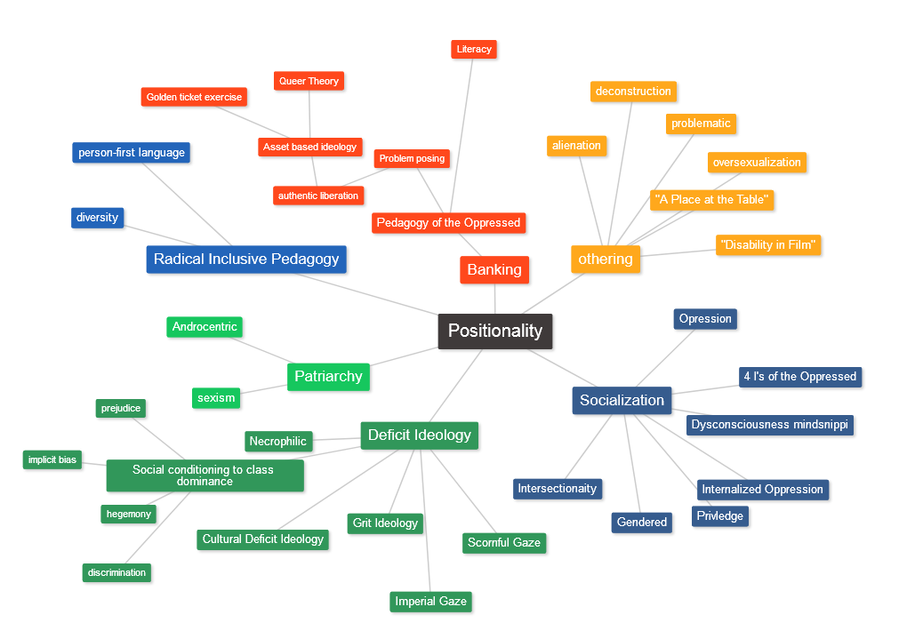

Option 5-Current Event Collaborative Concept Map:
Two or three students will collaboratively create a current event concept map, on a whiteboard, that visually centers a current event and connects it to key ideas and theories covered in class. Within the concept map, students should depict cause-and-effect relationships, theory and derivative theories, and theme and sub-themes. The current event collaborative concept map should identify at least 30 essential terms/concepts from current and prior weeks. Students should include four “in-progress” photos from beginning to end of the map design. All students must link the relevant current event article/blog to the map.

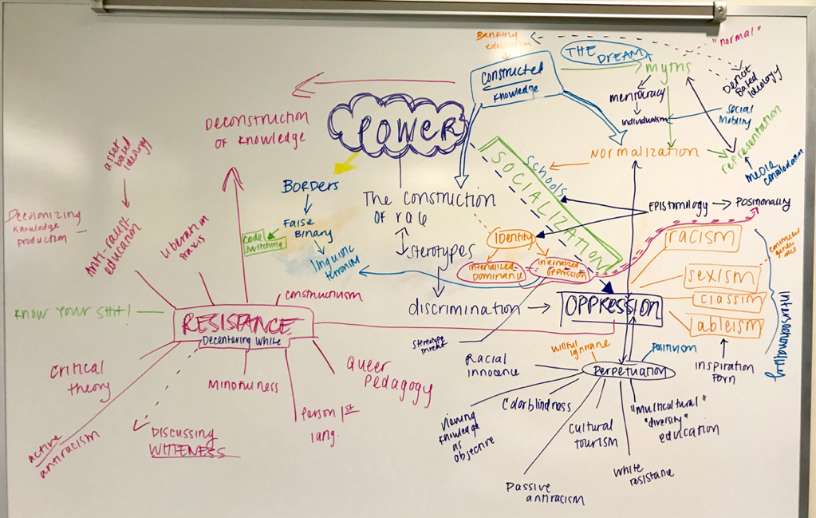

Synthesis Paper:
There will be one final assignment – a synthesis paper. I will distribute detailed guidelines for the synthesis paper in class closer to the due date. Graduate students will submit an expanded final paper.

*****

Grading Evaluation Structure (4 Credits)
Reading Annotations and Engaged Participation (6 checks) 30%
Integrative Concept Journal (5 submissions) 40%
Synthesis Essay 30%

Required Books
Robin DiAngelo, White Fragility: Why It’s So Hard for White People to Talk about Racism (Beacon Press, 2018)

In addition to the required book, we will read a selection of scholarly articles, book chapters, and poems. All of the readings are available as a PDF packet for download via the Blackboard course site. You MUST download and print the PDF reading packet. YOU MAY NOT EARN ANNOTATION CREDIT WITHOUT A PDF PACKET.

PDF Packet Order Instructions
To order a copy of the PDF packet visit https://www.gmuprinthub.com and complete the following steps:
- Click on Booklets (at bottom of page).
- Click on Bound Booklets.
- Select the following options:
  - How many pages in the document? = 1
  - How many pages ae black & white? = 447
  - Print single or double-sided = 2
  - Inside Paper Stock = 20lb White Standard
  - Cover Paper Stock = Clear Front & Black Back
  - Binding choices = Plastic coil
  - Turnaround time = select 2 days
- Total: $41.06

CRITICAL RACE STUDIES
ABBREVIATED DAY-BY-DAY SCHEDULE
FALL 2018
Our syllabus is a living document and there will be changes throughout the semester. Any updates or revisions will be announced in class and made available via Blackboard.

DATE | READING ASSIGNMENT  (TO BE COMPLETED BEFORE CLASS) | DUE DATES
WK 1  8/26 | “How Does it Feel to be a Problem?” DuBois on the Meaning of Race in America  Introduce syllabus and course expectations. | Place PDF binder order TODAY.
WK 2  9/10 | The Godfather of CRT: The Key Writings that Formed the Movement | Be sure to bring your PDF binder to class WITH detailed annotations.
Labor Day | We will not meet
WK 3  9/16 | Conceptualizing CRT: Whiteness as Property | Annotation check #1
WK 4  9/23 | The Roots of CRT: Policing Black Bodies | ICJ #1 Due by 11:59PM Monday night.
WK 5  9/30 | CRT and The Fact of Blackness | Annotation check #2
WK 6  10/7 | White Terror and the Fungibility of Black Flesh | ICJ #2 Due by 11:59PM Monday night
Columbus Day/Indigenous Peoples’ Day  10/14 | Class does not meet
WK 7  10/15  We meet on TUESDAY. | CRT Praxis: Deconstructing the Colorblind Paradigm | Annotation check #3
WK 8  10/21 | CRT Praxis: Facing White Fragility | ICJ #3  Due by 11:59PM Monday night
WK 9  10/28 | Branches of CRT: Tribal Critical Race Theory | Annotation check #4
WK 10  11/4 | Branches of CRT: Intersectionality and Critical Race Feminism | ICJ #4  Due by 11:59PM Monday night
WK 11  11/11 | Branches of CRT: LatCrit | Annotation check #5
WK 12  11/18 | Branches of CRT: QueerCRIT | ICJ #5  Due by 11:59PM Monday night.
WK 13  11/25 | Branches of CRT: DisCRIT/Crip Theory | Annotation check #6
WK 14  12/2 | Pulling it all together
 | Synthesis Essay Due 12/16 by 4:30PM via Blackboard

