PSYC 379-001 – Applied Cross-Cultural Psychology

This syllabus may change.
This syllabus has been updated as of 1/14/2019

Instructor: Mayra Parada E-mail: mparada2@gmu.edu
Office: David King Hall 1028
Office Hours: Wednesdays 11-12, or by appointment

Textbook

1. Matsumoto, D., & Juang, L. (2017). Culture and psychology (6th ed.). New York, NY: Cengage Learning.

2. Selected articles posted on Blackboard

Course Overview
Welcome to Applied Cross-Cultural Psychology! This course provides an overview of the theoretical and empirical developments currently defining the field of cross-cultural psychology. The course will emphasize empirical approaches to cross-cultural study and explain the importance of culture in human cognition, perception, intelligence, emotion, socialization, and mental health. Students will gain an understanding of explicit and implicit cultural messages, and how an individual's views about themselves, others, and the world around them can be shaped by these messages. The course is primarily conducted online, with several experiential exercises assigned throughout the semester. Course objectives include increasing students’ understanding of how culture influences mental processes and behavior, and enhancing students’ knowledge about cross-cultural research.
Course Goals
As the course instructor, I have several goals for each student to work toward during this semester:
1) An awareness of the hidden and obvious gender biases in the study of human behavior and an appreciation of the complexity of the research on gender issues
2) Clarification of the nature and development of gender differences and gender roles
3) Development of critical thinking and skill in evaluating gender in the media
4) Development of an intellectual tolerance and respect for others' viewpoints
5) Development of self-understanding and empowerment, appreciating that we need not be constrained by traditional gender roles and stereotypes

Course Format

This course will be held entirely online. Information will be presented in PowerPoint lectures, articles and assigned textbook readings. Students are responsible for understanding all of the information presented in articles, and in their textbook and these PowerPoint lectures.

Lectures
As stated above, this course will deliver content PowerPoint slides. These lectures will be posted on Blackboard at the beginning of the semester. PowerPoints will include key terminology, important concepts, and detailed information.

Students should use the textbook to supplement their knowledge and understanding of the information presented in these slides. If students are unsure about a specific concept, they should first consult their textbook for more information regarding this topic. If they are still unsure about a topic, they may email the instructor.

Participation
Students are expected to attend each schedule lecture day unless due to illness, injury, family emergency, or any other excruciating circumstances. Attendance will not be taken nor tracked. However, students can expect five (5) class activities randomly throughout the semester. Each class activity is worth 1% of your overall grades. You must be present to receive participation credits. No exceptions.

Final Presentation
The end of the semester will culminate into a final presentation. Students are expected to join a group of 2-3 and present on a program of choice. This program must be a program tailored for children (birth-18 years old) and families such as Head Start, gang intervention programs, Sex education programs, etx. However, you must choose and research an established program. Presentations are held during the last two (2) scheduled lecture days and must present in front of a panel of judges to request improvement funds for your program. Final presentations must include:
- History of program
- Rationale for establishment of program
- Outcomes of program
- Cultural Competency Gap
- Recommendations for cultural competency

Empirical Article Summary and Critique
Students will select an empirical article/research study with human subjects (not a review or meta-analysis) of their choice from the Journal of Cross-Cultural Psychology. Students must write a 3-5 page summary (no more than 1 page) and critique of the article. The brief paper should start with a summary of what the researchers did, with whom, why it is interesting/important, and what the authors found. Then you must connect the article explicitly to at least three (3) concepts, theories, or ideas we have discussed in the course (both in terms of methodology/research methods and content), plus mention at least two (2) methodological strengths and two (2) methodological problems/criticisms that you perceive of the study. Must be in general APA format (double-spaced, Times New Roman font, size 12)

Midterm and Final Exam
Two exams are completed throughout the semester. This includes the midterm exam and the final exam. Each exam includes 100 multiple choice questions (each worth 2 pts) and are available at midnight on the scheduled date. Please see the schedule for specific dates. Student should spend ample time studying all of the materials from each of the chapters before embarking on this final exam. Only one opportunity is given to complete this exam. Once answers are submitted, grades are posted automatically to Blackboard. To ensure that students do not cheat, limited time is given to complete the exam.

Students must complete this final exam by the following Monday at midnight receive credit for this exam. Students who fail to complete exams by due date automatically receive a grade of 0%. There will be NO exceptions. This exam will account for 20% of a student’s overall grade in the course.

Grade Breakdown

Exams ………………………………………………………………………60% (30% each)
Presentation ………………………………………………………………...20%
Article Critique …………………………………………………………….15%
Participation …………………………………………………………………5%
Total 100%
Grading Scale:
A+ = 97-100% B+ = 87-89% C+ = 77-79% D = 60-69%
A = 93-96% B = 83-86% C = 73-76% F = <60%
A- = 90-92% B- = 80-82% C- = 70-72%

Additional Information

Email Policies
For questions regarding course content, please email the instructor – mparada2@gmu.edu
Please make sure you re-read the syllabus before asking questions about the policies, procedures, or format of the course.
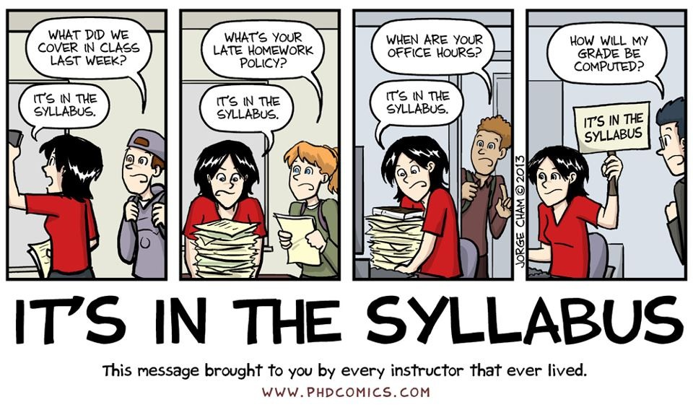
Official Communications via GMU E-mail: Mason uses electronic mail to provide official information to students. Examples include communications from course instructors; notices form the library, notices about academic standing, financial aid information, class materials, assignments, questions, and instructor feedback. Students are responsible for the content of university communication sent to their mason e-mail account, and are required to activate that account and check it regularly. I can only respond to gmu.edu email addresses, so please only use your Mason email in correspondence with me.

Blackboard: I will post notes, resources, grades, and announcements on Blackboard. You should frequently check Blackboard because you will be responsible for the material posted. Additionally, all assignments will be turned in through Blackboard. To use Blackboard you will need to go to https://mymasonportal.gmu.edu.

Honor Code: Coursework is expected to be the student’s own original work. Students may use books, notes, and other sources to prepare assignments. Under no circumstances are students to collectively write papers with another student, turn in work previously submitted, reference notes or class materials during tests, or use material from other sources (textbook, websites, journal articles etc.) without proper citation (APA style). This will be considered plagiarism and will not be tolerated. All George Mason University students have agreed to abide by the letter and the spirit of the Honor Code. You can find a copy of the Honor Code at academicintegrity.gmu.edu. All violations of the Honor Code will be reported to the Honor Committee for review. I reserve the right to enter a failing grade for any student found guilty of an honor code violation.

Disability Accommodations: If you have a documented learning disability or other condition that may affect academic performance you should: 1) make sure this documentation is on file with Office of Disability Services (SUB I, Rm. 4205; 993-2474; http://ods.gmu.edu) to determine the accommodations you need; and 2) talk with me to discuss your accommodation needs.

Course Schedule
Date | Content | Chapter | Reading
Week 1
Tues – Jan 22 | Overview of Course & Syllabus
Thurs – Jan 24 | Culture - Foundations | Ch. 1
Week 2
Tues – Jan 29 | Cross-Cultural Methods | Ch. 2
Thurs – Jan 31 | Enculturation & Acculturation | Ch. 3 | Immigrant paper
Week 3
Tues – Feb 5 | Culture and Developmental Processes | Ch. 4
Thurs – Feb 7 | Culture and Developmental Processes | Ch. 4 | SRCD Report
Week 4
Tues – Feb 12 | Culture, Schooling, & Teaching Styles | Ch. 5
Thurs – Feb 14 | Culture, Self, & Identity – White privilege | Ch. 5 | White Privilege paper
Week 5
Tues – Feb 19 | Culture, Self, & Identity
Thurs – Feb 21 | Culture & Personality | Ch. 6
Week 6
Tues – Feb 26 | Culture & Gender | Ch. 7
Thurs – Feb 28 | Culture & Gender | Ch. 7
Week 7 – Midterm Exam
Tues Mar 5 | Thurs Mar 7
Week 8 – Spring Break No Class
Week 9
Tues – Mar 19 | Culture & Cognition | Ch. 8
Thurs – Mar 21 | Culture & Cognition | Ch. 8
Week 10
Tues – Mar 26 | Culture & Emotion | Ch. 9
Thurs – Mar 28 | Culture & Emotion | Ch. 9
Week 10
Tues – Apr 2 | Culture, Language, & Communication | Ch. 10 | Bilingualism paper
Thurs – Apr 4 | Culture, Language, & Communication | Ch. 10 | AAVE paper
Week 11
Tues – Apr 9 | Culture & Health | Ch. 11 | Article Critique Due
Thurs – Apr 11 | Culture & Health | Ch. 11
Week 12
Tues – Apr 16 | Culture & Psychological Disorders | Ch. 12
Thurs – Apr 18 | Culture & Treatment for Psych Disorders | Ch. 13
Week 13
Tues – Apr 23 | Culture & Social Behavior | Ch. 14
Thurs – Apr 25 | Culture & Social Behavior | Ch. 13
Week 14
Tues – Apr 30 | Student Presentations | Ch. 13
Thurs – May 2 | Student Presentations | Ch. 13
Week 15
Tues – May 7 | Reading Day
Thurs – May 9 | Final Exam

*This syllabus is subject to change. Please listen to lectures and monitor the course website
regularly to be informed of any changes made to the course.*

Last Day to Add: January 29
Last Day to Drop (no tuition refund): February 12

