Community Engagement for Social Change (PSYC 427-001)

Professor: Kris Gebhard, M.A. | Teaching Assistant: Syeda Younus Buchwach
Office: David King Hall 1004G (Knock on the 1004 door) | Office: David King Hall 1004G
E-Mail: kgebhard@gmu.edu | E-Mail: syounus1@gmu.edu
Office Hours*: Tuesdays 12:15-1:15pm *Please email if you’re coming | Office Hours: Wednesdays 1:30-2:30pm
Class time and location: Tuesdays/Thursdays 1:30 – 2:45pm, Robinson B 122

Course Description
This class explores influences on social problems and approaches to addressing them by drawing from the perspectives of multiple disciplines. By definition, a social problem is a problem that affects many people, but such issues are often viewed primarily as individual-level problems that require individual-level solutions. In this class, students will learn to understand social problems and approaches to addressing them at both the individual level (typically the focus of fields such as Clinical Psychology) and the social level (typically the focus of fields such as Community Psychology, Sociology, and Public Affairs). The class will achieve its goals through a semester-long case example of the social problem of poverty. We will explore this social problem through students’ service to community organizations, readings, class exercises and both written and oral projects.

Goals
In this course, students will:
- Identify and understand the individual, interpersonal and social context levels of a social problem, drawing from the perspectives of multiple disciplines.
- Identify and understand approaches toward targeting different aspects of a social problem.
- Apply the above skills (multi-level analysis of social problems) in oral and written products.
- Complete a minimum of 20 hours of service to a community organization coordinated by the instructor and in the context of this service:
  - Deepen understanding of a social problem through contact with both people it affects and people trying to do something about it
  - Provide concrete value to the community organization
  - Connect course concepts to concrete experiences

Requirements
Participation (30%). Students are required to participate in discussions and exercises throughout the semester, including some exercises that require preparation before class (15%). For every class for which there is not a homework assignment due, students are required to be prepared for every class as evaluated by entries in a critical reading journal (15%). Instructions for the journal will be distributed through Blackboard. Entries must be submitted via Blackboard by 5pm on the day of class in order for students to receive credit. The two lowest scores on these activities will be dropped, and there will be no make-ups.

Connection Papers (20%). Students will be required to write 2 three-page double-spaced connection papers in response to prompts from the instructor throughout the course of the semester. Prompts and papers will be posted on Blackboard. Due dates are: Tuesdays 10/9 and 11/13. Papers are due by the start of class on the day they are due.
You may re-write one connection paper. This re-write will be graded using the same rubric used to grade the original paper, and the best grade will be counted towards your overall grade. You may only re-write ONE connection paper this semester. In order to re-write a connection paper, you must have originally turned it in in time to receive credit.
The deadline to submit a re-written connection paper is November 27.

Final project (30%): The final project consists of a paper and an in-class poster presentation. Students will work in groups during the semester to analyze a social issue of interest to them, other than poverty. Each student will write a 4-6 page paper using scholarly sources to conduct a multilevel analysis of the social problem, similar to the one that will be conducted in class on poverty. Students will then identify a program or organization that targets that problem. Students will submit the paper via Blackboard on December 6 by 1:30pm. As a group, students will then construct a poster (on poster board or a large poster paper) that provides an overview of the social problem, the organization that works to address it, and the strengths and weaknesses of the organization in addressing the social issue. During final exam time, there will be a poster session in which students share their project with others, view other students’ work, and rate their peers’ posters.

Policy for late assignments: With the exception of journal entries which may NOT be handed in late, assignments handed in up to 24 hours past the deadline will be downgraded by 15%; up to 48 hours they will be downgraded by 50%; after 48 hours they will not be accepted.

Service (20%): A fundamental goal and requirement of this class is to provide concrete value to our partner organizations in exchange for the experience we are gaining. These partnerships have been developed by the instructor, and students will choose from available placements at the outset of the course. Students will be provided with information about the requirements of the placement in order to guide their choice. Students who do not complete the requirements they agree to when they choose a placement will receive a failing grade for the course. Across placements, the minimum number of hours you will total over the course of the semester is 20, plus approximately two hours of orientation. (Placements involving tutoring may require more training, as they involve curriculum.) The academic (readings, exams) workload in this class is relatively light, because the service is meant to be the core of the substance of the course. Your reliable engagement in your service placement is essential. Your grade for this requirement will be assessed at 2 points and then averaged:
- At mid-term check-in (Oct 9), at which time you must have:
  - Chosen a placement and documented your understanding of the requirements on the class Google spreadsheet.
  - Completed orientation and/or training at your placement, and documented this on the Google spreadsheet.
  - Met expectations according to supervisor report.
  - Completed at least 5 hours of service, as documented on the spreadsheet (if you do not document it, it did not happen).
- At final grade submission, at which time you must have:
  - Completed the minimum of 20 hours, as documented on the spreadsheet (by 12/18).
  - Met expectations according to supervisor report.

Grade Breakdown

In-class participation 15%
Critical Reading Journals (dropping the lowest 2 of in-class participation / CRJs) 15%
Connection Paper 1 10%
Connection Paper 2 10%
Service 20%
Final Project 30%

Total 100%

Grading Scale:
I will calculate your final grade on your point total as follows: 93-100 = A; 90-92 = A-; 87-89 = B+; 83-86 = B; 80-82 = B-; 77-79 = C+; 73-76 = C; 70-72=C-; 65-69 = D; below 65 = F.

Official Communications via GMU E-mail: Mason uses electronic mail to provide official information to students. Examples include communications from course instructors, notices from the library, notices about academic standing, financial aid information, class materials, assignments, questions, and instructor feedback. Students are responsible for the content of university communication sent to their mason e-mail account, and are required to activate that account and check it regularly.

If you email the instructor, please use the prefix "PSYC 427-" in the subject line of email. This will allow them to more readily identify your email and respond in a timely manner.

Email Policies
For questions regarding course content, please email the instructor – kgebhard@gmu.edu
Please make sure you re-read the syllabus before asking questions about the policies, procedures, or format of the course.
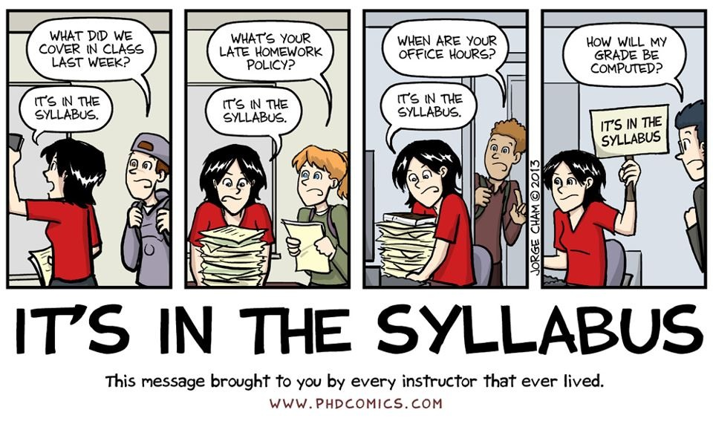

Honor code:
The Honor Code of George Mason University deals specifically with cheating and attempted cheating, plagiarism, lying, and stealing. Students should be familiar with the code and connected policies, set out at http://www.gmu.edu/catalog/apolicies. This course will be conducted in accordance with those policies.

Accommodations for students with disabilities:
If you are a student with a disability and you need academic accommodations, please see me and contact the Disability Resource Center (DRC) at 703-993-2474. All accommodations must be arranged through that office, and must be initiated immediately, prior to any anticipated need.

*READINGS ARE SUBJECT TO CHANGE THROUGHOUT THE SEMESTER

Course Schedule
Date | Content & Assignment Due Dates | Course Readings  Readings available on Blackboard  (See full citations below)
Aug. 28 | What is Service Learning?  Launching placements and connections to course content | * Cress, Collier, Reitenauer, & Associates, 2005. Ch 1.
Aug. 30 | What is Service Learning?  Launching placements and connections to course content  Cress Exercise 2.4 due | * Cress, Collier, Reitenauer, & Associates, 2005. Ch 2.
Sept. 4 | Understanding social issues through multi-level analysis  Critical reading journal due | * Ryan, 1971. Intro & Ch 1.
Sept. 6 | Understanding social issues through multi-level analysis  Critical reading journals due | * Dalton, Elias, & Wandersman, 2007
Sept. 11 | Setting the stage for our case study: wealth and power in the US  Critical reading journal due | * Velonis, et al., 2017  * Watch this TED talk: http://www.ted.com/talks/richard_wilkinson.html
Sept. 13 | Setting the stage for our case study: wealth and power in the US  Critical reading journal due | * Irwin (2017) To Understand Rising Inequality, Consider the Janitors at Two Companies, Then and Now.  * Complete the pages on this interactive website: http://inequality.is/
Sept. 18 | Intro to wealth inequality as a case study  Critical reading journal due | * Smith, 2010. Ch 2
Sept. 20 | Intro to wealth inequality as a case study  Critical reading journal due | * Collins, 2017 pp 9-33.
Sept. 25 | Wealth inequality as a case study: Social context level aspects  Critical reading journal due | * Listen to “512, House Rules,” an episode  from the radio show This American Life:  https://www.thisamericanlife.org/radio-archives/episode/512/house-rules
Sept 27 | Wealth inequality as a case study: Social context level aspects  Critical reading journal due | * Chetty and Herndon, 2015
Oct. 2 | Wealth inequality as a case study: Social context level aspects  Critical reading journal due | * Collins part 3: Understanding Advantage
Oct. 4 | Wealth inequality as a case study: Social context level aspects  Submit evidence for and against raising minimum wage (3 pieces each) | * Listen to this discussion of the debate about raising the minimum wage: http://thedianerehmshow.org/shows/2016-04-05/california-raises-its-minimum-wage-to-15-an-hour
Oct. 9 | NO CLASS – COLUMBUS DAY Connection Paper #1 due by 1:30pm MIDTERM CHECK-IN
Oct. 11 | Wealth inequality as a case study: Social context level aspects  Critical reading journal due | * Gorski, 2009
Oct. 16 | Wealth inequality as a case study: Social context level aspects  Critical reading journal due | * Pager, 2008  * Crosley-Corcoran, G., 2014 - Explaining  White Privilege…Accessible at:  http://www.huffingtonpost.com/gina-  crosleycorcoran/explaining-white-privilege-to-  a-broke-white-person_b_5269255.html
Oct. 18 | Wealth inequality as a case study: Interpersonal level aspects  Critical reading journal due | * Belle & Doucet, 2003
Oct. 23 | Wealth inequality as a case study: Interpersonal level aspects  Critical reading journal due | * Ehrenreich, 2008
Oct. 25 | Wealth inequality as a case study: Interpersonal level aspects  Critical reading journal due | * Your choice:  Piff, et al., 2012 OR  Piff, 2014
Oct. 30 | Wealth inequality as a case study: Individual level aspects  Critical reading journal due | * Smith, 2010. Ch 4.
Nov. 1 | Guest Speakers: National Coalition for the Homeless
Nov. 6 | Wealth inequality as a case study: Individual level aspects  Critical reading journal due | * Goodman et al., 2009
Nov. 8 | Wealth inequality as a case study: Individual level aspects  Critical reading journal due | * Boo, 2001
Nov. 13 | Wealth inequality as a case study: Individual level aspects  Critical reading journal due  Connection Paper #2 due 1:30pm | * Piff and Moskowitz, 2017
Nov. 15 | Guest Speaker: Rachel Isreeli, MSW  Critical reading journal due | * Niki Okuk TED talk: https://www.ted.com/talks/niki_okuk_when_workers_own_companies_the_economy_is_more_resilient
Nov. 20 | Identifying and addressing multiple aspects of social problems  Critical reading journal due | * Krosch & Amodio, 2014
Nov. 22 | NO CLASS – THANKSGIVING
Nov. 27 | Extending our analysis to other social problems  E.g., education inequality  Critical reading journal due  Optional Connection Paper Re-write due | * Listen to Back to School, an episode from  the radio show This American Life.  Accessible at:  https://www.thisamericanlife.org/radio-archives/episode/474/back-to-school
Nov. 29 | Extending our analysis to other social problems  E.g., mass incarceration  Critical reading journal due | * Watch this TED talk, The Future of Race in America: https://www.youtube.com/watch?v=SQ6H-Mz6hgw
Dec. 4 | Extending our analysis to other social problems  E.g., mass incarceration | * Alexander, M. (2010) The New Jim Crow. The New Press. (Introduction).
Dec. 6 | Wrap up and work-shopping for final projects  Submit Final Paper
Dec. 18  1:30 – 4:15pm | Final exam day: Poster Session

- * Last day to add class: September 3. Last day to drop without penalty: September 9.
- Web withdrawal period, with 100% tuition penalty: September 10-30
- Selective withdrawal period, with 100% tuition penalty: October 1-28
** In the event that class is canceled, I will notify you via email. If class is canceled due to inclement weather, check your email. I may video lecture via Blackboard during our class time, and will likely post a class make-up assignment on Blackboard.

Course Readings

All readings are posted on Blackboard; readings on websites are linked in the syllabus as well.

Alexander, M. (2012). The new Jim Crow: Mass incarceration in the age of colorblindness. The New Press. Introduction.
Belle, D. & Doucet, J. (2003). Poverty, inequality, and discrimination as sources of depression among U.S. women. Psychology of Women Quarterly, 27, 101-113.
Boo, K. (2001, April 9). Working two jobs, Elizabeth Jones does her best for her family. But is it enough? The New Yorker.
Brooks-Gunn, J., & Duncan, G. J. (1997). The effects of poverty on children. The Future of Children, 55-71.
Cress, C., Collier, P.J., Reitenauer, V.L. and Associates (2005). Learning through serving: A student guidebook for service-learning across the disciplines. Sterling, VA: Stylus. Ch 1 & 2.
Dalton, J.H., Elias, M.J. & Wandersman, A. (2007). Community psychology: Linking individuals and communities (2nd edition). Thompson Wadsworth: Belmont, CA (p.17-21).
Economic Policy Institute. (September 4, 2011). A lost decade: Poverty and income trends continue to paint a bleak picture for working families. http://www.epi.org/publication/lost-decade-poverty-income-trends-continue/
Ehrenreich, B. (2008). Nickel and Dimed: On (Not) Getting by in America. New York: Holt Paperbacks. Introduction and chapter 1.
Excerpt from Goodman, L.A., Smyth, K.F., Borges, A.M. & Singer, R. (2009). When crises collide: How intimate partner violence and poverty intersect to shape women’s mental health and coping. Trauma, Violence & Abuse, 10, 306-328. Handout.
Farmworker Justice. Weeding out abuses: Recommendations for a law-abiding farm labor system, (p.1-13).
Gorski, P. (2008, April). The myth of the “culture of poverty.” Educational Leadership, 32-36.
Irwin, N. (2017, September 3). To Understand the Rising Inequality, Consider the Janitors at Two Top Companies, Then and Now. The New York Times. Retrieved from https://www.nytimes.com/2017/09/03/upshot/to-understand-rising-inequality-consider-the-janitors-at-two-top-companies-then-and-now.html?action=click&module=Featured&pgtype=Homepage
Krosch, A. R., & Amodio, D. M. (2014). Economic scarcity alters the perception of race. Proceedings of the National Academy of Sciences, 111(25), 9079-9084.
Pager, D. (2008). The dynamics of discrimination. In A. Chih Lin and D.R. Harris (Eds.) The Colors of Poverty: Why Racial and Ethnic Disparities Persist. New York: Russell Sage, Ch 2.
Piff, P. K. (2014). Wealth and the inflated self: Class, entitlement, and narcissism. Personality
and Social Psychology Bulletin, 40(1), 34-43.
Piff, P. K., Kraus, M. W., Côté, S., Cheng, B. H., & Keltner, D. (2010). Having less, giving
more: the influence of social class on prosocial behavior. Journal of personality and social psychology, 99(5), 771.
Piff, P. K., & Moskowitz, J. P. (2017). Wealth, Poverty, and Happiness: Social
Class Is Differentially Associated With Positive Emotions. Emotion. Advance online publication.
Ryan, W. (1971). Blaming the victim. New York: Vintage Books. Introduction & chapter 1.
Simon, D. & Burns, E. (1997). The Corner: A year in the life of an inner-city neighborhood. New York: Broadway Books. (pp. 57-70, 74-75, 88-99).
Smith, Laura (2010). Psychology, Poverty and the End of Social Exclusion. New York: Teacher’s College Press. Chapter 2: “Classism.”
Tough, P. (2011, March 21). The poverty clinic. Can a stressful childhood make you a sick adult? The New Yorker.

