PSYC 418-DL1 – Applied Cross-Cultural Psychology

This syllabus may change.
This syllabus has been updated as of 06/02/2018

Instructor: Angelique B. Williams Office: 1028 David King Hall
Office Hours: Tuesday 1 - 3 Scheduled using google hangout angelique.b.williams@gmail.com (Angelique Williams) by appointment.
Email: awilli93@masonlive.gmu.edu

Textbook
The majority of resources used throughout this semester will consist of selected articles and book chapters posted on Blackboard.

Textbook referenced throughout the semester (not required text)

Corr, C., Corr, D., & Doka, K. Death & dying, life & living.

Course Overview
Welcome to Death, Dying and Grieving! This course provides an overview of varying perspectives surrounding death. The course will emphasize empirical approaches to the process of death, dying and grieving. Students will gain an understanding of a number of the processes and decisions that surround dying and death.

Course Goals
As the course instructor, I have several goals for each student to work toward during this semester:
Advanced survey of processes of grieving and their relationship to death and dying. Topics include ways of dying, effects of death on loved ones, and care for the terminally ill.

1) Understanding the process of death on an individual and collective level.
2) Development of a general familiarity with thanological research.
3) Understanding the factors that attribute to death. Including societal factors, socioeconomic status, and systemic issues.
4) Advanced understanding of the grieving process and how impacts those who experience it.

Course Format

This course will be held entirely online. Information will be presented in PowerPoint lectures and assigned article readings. Students are responsible for understanding all of the information presented in articles, and in their PowerPoint lectures. For each of the chapters, students must complete a discussion post and discussion response (see below for more information regarding these discussion-based assignments.) These assignments are designed to ensure that students both have an understanding of the core course content as well as an ability to participate in classroom discussions in order to enrich their overall understanding of cross-cultural issues. These assignments will be due at specific dates throughout the semester. Throughout the semester, students will complete thought papers and a final project to ensure a complete and thorough understanding of all course materials. Although each of the assignments for this course have specific final due dates, students are allowed to complete all of these in advance. Thus, the pace of this course is somewhat flexible.

***Late Work Will Not Be Made Up***

Extra-Credit Assignments: There will be no extra credit assignments in this course. Please prepare for assignments accordingly.

PowerPoint Lectures

As stated above, this course will deliver content primarily through PowerPoint slides. These lectures will be posted on Blackboard at the beginning of the semester. PowerPoints will include key terminology, important concepts, and detailed information. Most of this information will be provided in text.

Students should use the articles to supplement their knowledge and understanding of the information presented in these slides. If students are unsure about a specific concept, they should first consult their articles for more information regarding this topic. If they are still unsure about a topic, they may email the instructor.

Discussion Posts

For each section covered, students must also post and respond to two posts on the Blackboard Discussion board (600-800 words). Students must answer a weekly question. They are able to use supplementary resources (such as interesting and relevant video, link, popular press article, scholarly article, or a quote from the textbook (when applicable) to supplement their discussion. Along with their post, students must provide an APA style citation of where the information was found, specific answers to the questions asked, and a detailed explanation of why the post relates to the question asked. The goal of these posts is to spur discussion among classmates, so they should be as thought-provoking and engaging as possible in order to encourage other students to read and respond. I encourage healthy discussions and debates through these discussion threads. However, rude, disrespectful and offensive posts will negatively impact the grade of the writer. Keep in mind that your opinion has as much place as every other student in the forum.

All discussion posts should include at least one reference which should be cited both in text and in the reference section of the discussion post.

Make sure that you write the post within the thread. Discussion board posts submitted as an attachment will not be read.

Students must also read and respond to a discussion post of at least two other classmates. These responses should include overall thoughts/ideas spurred by the post, other reasons why the post was interesting, other ways that the post was relevant to topics outlined within the course, aspects of the post that the student may agree/disagree with, and/or any other observations that the student would like to make about the post. These responses should also be at least 5 sentences (points will be deducted for incomplete or incoherent thoughts), and please remember to be respectful and polite regarding other students’ opinions when posting these responses. The professor reserves the right to deduct points based upon inappropriate or disrespectful conduct directed at other students or the professor themselves.

Grading Rubric for Discussion Board Post (10 pts total)

5pts…………………………………………………………………………………………Original post

These points are earned based upon the word count, grammar, content and references cited both in text and in the reference section at the end of the discussion post in the original post.

5pts……………………………………………………………………………………….. Responses

Each response is worth 2.5 points. These points are earned based upon depth of response (at least 5 lines), and grammar.

All Discussion posts are due on the Friday of each week before Midnight. (11:59 PM)

Writing Assignments/ Projects

There will be a weekly written assignment due at the end of each week. This writing assignment or small project is in some way related to the information that was covered within the lecture that week. Students should refer to the assignments tab on Black board for more detailed information concerning the specifics of their writing assignment. This is a 400-level college class – papers not submitted in APA format will not be reviewed. Any remaining questions concerning specifics of writing assignments after reviewing the guidelines listed can be brought to the instructor.

Also, it is understandable if citation generators are used to help students with creating an APA formatted reference section.

All Writing Assignments are due on the Friday of that specific week before Midnight. (11:59 PM)

Empirical Resources MUST be used for full credit:

“Empirical studies are those based on actual and objective observation or experimentation. Articles that describe empirical research studies are usually published in scholarly or academic journals.” You may also use academic sources such as books but should rely heavily on the GMU Library Database.”

All Assignments will be submitted using the Blackboard platform. NO EXCEPTIONS

Grade Breakdown

Writing Assignments/ Projects 60%
Obituary Assignment 10%
Advanced Directive Assignment 10%
Written Will Assignment 10%
Funeral Assignment 10%
Developmentally Appropriate Resources Assignment 20%
(Please note that the Developmentally Appropriate Resource assignment is worth double the points of other written projects. This is because this assignment will serve as the final projects of the semester.)
Discussion Posts 40%
Total 100%

Grading Scale:
A+ = 97-100% B+ = 87-89% C+ = 77-79% D = 60-69%
A = 93-96% B = 83-86% C = 73-76% F = <60%
A- = 90-92% B- = 80-82% C- = 70-72%

Additional Information

Writing Policies
As is the case with all writing projects assigned throughout the semester, proper grammar and formatting is important. Because this is a psychology class all assignments should be submitted in APA format. Errors will result in a reduction of the grade for that assignment. Please do not be afraid to use on campus resources such as the Writing Center, as well as contacting me for help! 😊 http://writingcenter.gmu.edu/

General Netiquette
Proper internet etiquette is required in this class. The grade of students who do not participate in the following code of conduct will be negatively impacted.
Common Rules of Netiquette (courtesy of University of Arizona’s Code of Student Conduct)
Reviewing netiquette guidelines written by others is a helpful way to determine appropriate standards for your own students. Many common rules fall under four categories:
- Be scholarly. Students should use proper language, grammar, and spelling. They should be explanatory, justify their opinions, and credit the ideas of others by citing or linking to scholarly resources. Students should avoid misinforming others when they may not know the answer to something. When students are discussing something, they are unsure about or supplying a guess, they should clearly state that.
- Be respectful. The privacy of others must be respected; students should avoid sharing personal or professional information about classmates. Students should respect diversity and opinions that differ from their own. Communication should be tactful, with disagreements based on scholarly ideas or research evidence.
- Be professional. Everyone should strive to look their best online.² Truthfulness, accuracy, and running a final spell check are appropriate expectations for university students. Writing in a legible font and limiting the use of emoticons is considered professional behavior. Profanity and participation in hostile interactions, known as flaming, is unprofessional as well as disruptive.
- Be polite. Students should be addressing professors and instructors by the appropriate title or requested name. Students should also address each other by name and be mindful of their written tone. Students should interact online politely, just as they would be expected to do in a physical classroom environment. Sarcasm, rudeness, crass language and writing in all capital letters (shouting) should be avoided.
Discussion Board Netiquette
Common discussion board rules, in addition to the use of proper spelling and grammar, are:
- Read all other comments before posting. Students should contribute by adding to the discussion, not by repeating in their own words what others have already posted. In addition, other students may have posted questions about the course or an assignment that have already been answered within the discussion board.
- Be clear and stay on topic. Be clear about what you are saying so that it is not misunderstood. Read your words aloud before posting to test the clarity of your message.
- Be mindful of your tone. The tone of messages in an academic environment should be polite and display respect for others. The use of sarcasm, profanity, and ALL CAPS (shouting) should be avoided.
- Be credible. Do not mislead other students by providing information that might not be accurate. If your response is a guess, state that clearly. Be sure to give credit where it is due by citing sources, providing links, or crediting the ideas of other classmates.
- Respect diversity. Online courses bring students together from all over the world. Recognize that others may have different cultural backgrounds and skill levels with writing in the English language. Treat others with respect, regardless of race, gender, religious beliefs, and sexual orientation. Additionally, be respectful when opinions differ from your own; disagree in a polite manner.

Email Policies
For questions regarding course content, please email the instructor – awilli93@gmu.edu
Please make sure you re-read the syllabus before asking questions about the policies, procedures, or format of the course.
When emailing the instructor or teaching assistant regarding the class, you MUST include PSYC 380 in the title of the email. This ensures that the instructor can easily identify course-related emails and respond in a timely manner.

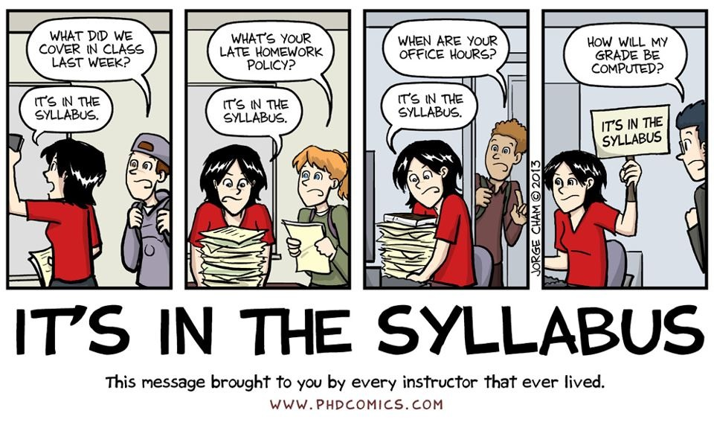

Official Communications via GMU E-mail: Mason uses electronic mail to provide official information to students. Examples include communications from course instructors; notices form the library, notices about academic standing, financial aid information, class materials, assignments, questions, and instructor feedback. Students are responsible for the content of university communication sent to their mason e-mail account and are required to activate that account and check it regularly. I can only respond to gmu.edu email addresses, so please only use your Mason email in correspondence with me. Also, please make sure that you draft all emails in a grammatically correct manner. Emails that do not include a salutation and full sentences will not be answered.

Blackboard: I will post notes, resources, grades, and announcements on Blackboard. You should frequently check Blackboard because you will be responsible for the material posted. Additionally, all assignments will be turned in through Blackboard. To use Blackboard, you will need to go to https://mymasonportal.gmu.edu.

Honor Code: Coursework is expected to be the student’s own original work. Students may use books, notes, and other sources to prepare assignments. Under no circumstances are students to collectively write papers with another student, turn in work previously submitted, reference notes or class materials during tests, or use material from other sources (textbook, websites, journal articles etc.) without proper citation (APA style). This will be considered plagiarism and will not be tolerated. All George Mason University students have agreed to abide by the letter and the spirit of the Honor Code. You can find a copy of the Honor Code at academicintegrity.gmu.edu. All violations of the Honor Code will be reported to the Honor Committee for review.

Disability Accommodations: If you have a documented learning disability or other condition that may affect academic performance you should: 1) make sure this documentation is on file with Office of Disability Services (SUB I, Rm. 4205; 993-2474; http://ods.gmu.edu) to determine the accommodations you need; and 2) talk with me to discuss your accommodation needs.

Course Schedule
Week | Date | Assigned Reading | Assignments for the week
Module #1 – Death
1 | 8/27– 8/31 | Week 1 PowerPoint Slides  Keim, Fortney, Shultz, Winning, Gerhardt, & Baughcum (2017)  Yanke, Rady, & Verheijde (2016) | Introduction Post  Discussion Post #1
2 | 09/04 - 09/07 | Week 2 PowerPoint Slides  Death Be Not Proud  Grinshteyn & Hemenway (2010) | Discussion Post #2
3 | 09/10 – 09/14 | Week 3 PowerPoint Slides  Why Does The Yanomami Tribe Eat the Ashes of the Dead? | Discussion Post #3  Obituary Assignment
Module 2: Dying
4 | 09/17 – 09/21 | Week 4 PowerPoint  Watch A Millionaire’s First Love | Discussion Post #4
5 | 09/24 – 09/28 | Week 5 PowerPoint  Corr (2015)  Parkes (2013) | Discussion Post #5  Funeral Assignment
Module 3: Bereavement
6 | 10/01 – 10/05 | Week 6 PowerPoint  Eisma, Boelen, Schut & Stroebe (2017)  Tonkins & Lambert (1996) | Discussion Question #6
7 | 10/08 – 10/12 | Week 7 PowerPoint  Boelen, Spuij & Reijntjes (2017)  Balk, Zaengel & Corr (2011) | Discussion Question #7  Written Will Assignment
Module 4: Moral Issues
8 | 10/15 – 10/19 | Week 8 PowerPoint  Wilson (2018) | Discussion Question #8
9 | 10/22 – 10/26 | Week 9 PowerPoint  Velazquez et al. (2017)  Watch Haneri Short Movie | Discussion Question #9
10 | 10/29 – 11/02 | Week 10 PowerPoint  Related Advanced Directive Articles/Resources | Discussion Question #10  Advanced Directive Assignment
Module 5: Developmental Perspectives
11 | 11/05 – 11/09 | Week 11  Kaufman & Kaufman (2016)  Watch Lifetimes Short Movie | Discussion Question #11
12 | 11/12 – 11/16 | Week 12 PowerPoint  Stikkelbroek, Bodden, Reitz, Vollebergh, & van Baar (2016)  Creighton, Oliffe, Matthews, & Saewyc (2016) | Discussion Question #12
13 | 11/19 – 11/23 | Thanksgiving Break
14 | 11/26 – 11/30 | Week 14 PowerPoint  Jenkins, Edmundson, Averett & Yoon (2014)  Naef, Ward, Mahrer-Imhof & Grande (2013) | Discussion Question #13
15 | 12/03 – 12/07 | Focus on Submitting Your Final! | Developmentally Appropriate Resource Assignment.

*This syllabus is subject to change at the discretion of the professor. Students are responsible for all information presented regardless of their reading of the syllabus. *

Important Dates to Know

Last Day to Add/Drop (with no tuition penalty): Wednesday, June 27, 2018
Last Day to Drop (50% tuition penalty): Monday July 9, 2018
Last Day to Drop **selective withdrawal period** (100% tuition penalty): July 10 – 18, 2018

