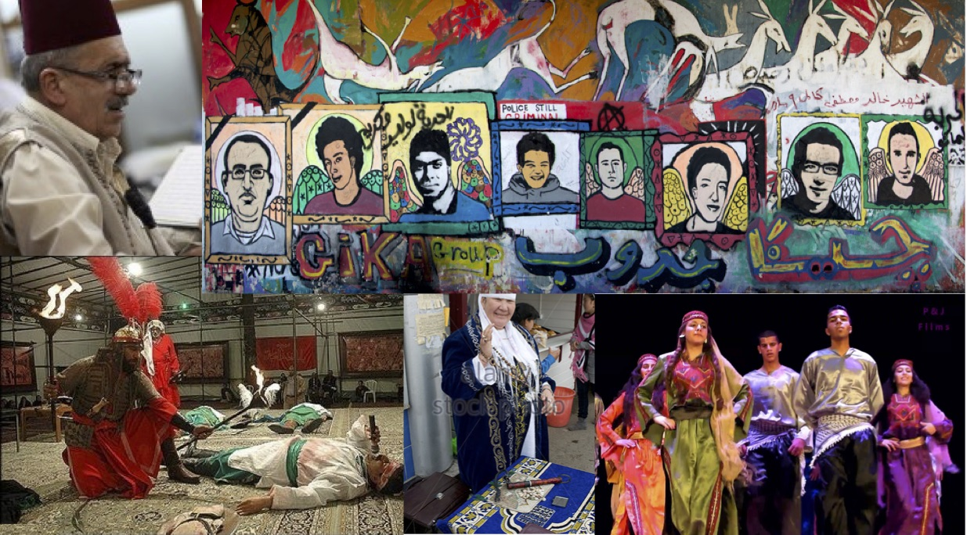

English 412/591
Folklore in the Middle East and Central Asia
Fall 2017
M 4:30-7:10pm

Instructor: Prof. Benjamin Gatling
Office: Robinson Hall A 441
Phone: 703-993-1178
Email: bgatling@gmu.edu

This course surveys folklore and expressive culture across the greater Middle East and Central Asia, from Egypt and Palestine to Iran, Afghanistan, and the former Soviet Central Asian republics. We’ll explore a range of expressive forms by reading ethnographic case studies about oral poetry and epic, graffiti, dream interpretation, popular theater, storytelling, foodways, wedding customs, popular religious life, and more.

Through course readings, lectures, discussions, and written assignments, we’ll pay special attention to the politics of folklore and investigate how expressive culture is central to negotiations of power, strategies of resistance, and constructions of identity. You’ll gain an understanding of folklore’s foundational importance in both reflecting and shaping how individuals and states across the Middle East and Central Asia imagine the self and nation.

READINGS

You are required to purchase four books:
- Abu-Lughod, Lila. 1999. Veiled Sentiments: Honor and Poetry in a Bedouin Society. Berkeley: University of California Press. ISBN 0-520-22473-6
- Adams, Laura. 2010. The Spectacular State: Culture and National Identity in Uzbekistan. Durham, Duke University Press. ISBN 978-0-822-34643-2
- McDonald, David. 2013. My Voice in My Weapon: Music, Nationalism, and the Poetics of Palestinian Resistance. Durham: Duke University Press. ISBN 978-0-8223-5479-6
- Mittermaier, Amira. 2011. Dreams that Matter: Egyptian Landscapes of the Imagination. Berkeley: University of California Press. ISBN 978-0-520-25851-8

Recommended Books:
- McNeil, Lynne S. 2013. Folklore Rules. Logan, UT: Utah State University Press. ISBN
978-0-97421-905-0

All other readings will be posted to Blackboard.

ASSIGNMENTS

English 412 (undergraduate)

- Reading Questions (RQs) 30%: Each week, you’ll be required to answer discussion questions about the week’s assigned readings. Questions will require you to highlight the main themes of the readings and reflect on their broader relationships to the focus of the course. Post your RQ on the course Blackboard discussion board by the beginning of class on the day it is due.
- Essay 1 20%: You’ll write an essay (~750 words) in response to the documentary, The Noise Of Cairo: Egypt's artistic revolution. Details will be distributed later.
- Essay 2 20%: You’ll write a review of the Turquoise Mountain exhibition at the Smithsonian’s Freer Sackler Museums of Asian Art. (http://www.asia.si.edu/exhibitions/current/turquoisemountain/). Details will be distributed later.
- Take-Home Final Exam 30%
English 591 (graduate):
- Reading Responses (RRs) 30%: Each week, you’ll craft a ~500 word reading response. Your response should bring out the main themes of the readings and highlight what you see as their broader implications, e.g. theoretical, methodological, etc., to the course. I’d especially like for you to connect the readings, where appropriate, to your own research and theoretical interests, evaluating their arguments in light of your work and suggesting how they might be useful to your ongoing projects. Lastly, pose some questions you’d like to see the class address in our weekly discussion. Post your RR on the course Blackboard discussion board by the beginning of class on the day it is due.
- Exhibit Review Essay 25%: You’ll write a review of the Turquoise Mountain exhibition at the Smithsonian’s Freer Sackler Museums of Asian Art. (http://www.asia.si.edu/exhibitions/current/turquoisemountain/). Details will be distributed later.
- Term Paper 45%: Using theoretical perspectives found in course readings and from outside research, you’ll write a term paper (~15-20 pages) connected in some way to your larger research project/interests. You must meet with me by 10/30 to decide on a topic. If you do not meet with me and get my approval, I will not accept your final paper. For suggestions on writing your abstract, due 10/2, see https://theprofessorisin.com/2011/07/12/how-tosday-how-to-write-a-paper-abstract/.
Special Note for MFA Students: In lieu of a term paper, MFA students may complete an alternative creative project. MFA students should submit at least ten pages (no maximum) of new creative writing (poetry, fiction, creative non-fiction, etc.). Students should also write a reflection and analysis (at least five pages) on the role of personal narratives within their writing and writing process. In the reflection, students should comment on the insights they’ve gained from our course readings, discussions, etc. related to the folklore in the Middle East and Central Asia. Students should refer directly to course readings in their reflection/analysis.
GRADING SCALE

95-100 A 80-82 B- 67-69 D+
90-94 A- 77-79 C+ 63-66 D
87-89 B+ 73-76 C 60-62 D-
83-86 B 70-72 C - <59 F

COURSE POLICIES

Attendance/Participation: You are expected to attend every class. The course will be taught in a seminar format. This means that participation from you, the student, is vital to successful completion of the course. Participation includes: 1) doing the assigned readings and RRs/RQs and 2) participating actively in class discussions. Consistent failure to do either will result in a lowered final grade. Participation also includes bringing hard copies of readings to class and/or being able to access electronic copies of each day’s readings.
Under no circumstances are you allowed to text or surf the Internet on your mobile phone or laptop in class.
Late Work: Late submissions will be accepted but will receive a penalty of one letter grade per calendar day (11:59 PM to 11:59 PM) late, including weekends and holidays.

Plagiarism: I will follow all university procedures on academic misconduct. Plagiarism will not be tolerated. I encourage you to consult GMU’s Writing Center’s guide to avoiding plagiarism: (http://writingcenter.gmu.edu/?p=499). For more information on GMU’s Honor Code and its requirements, see http://honorcode.gmu.edu.

Special Accommodations: Students with disabilities who believe they may need accommodations in this class are encouraged to contact the Student Disability Access Office (http://ods.gmu.edu) as soon as possible.

Availability and Office Hours: My preferred communication method is email. I will do my best to respond to each email within twenty-four hours. I am also more than happy to arrange a time to meet with you outside of class. Please email me to schedule an appointment.

COURSE WEBSITE

The syllabus, class schedule, and selected readings are posted on the course myMason/Blackboard site. Unless otherwise stated, all assignments should be submitted electronically under the “Assignments” tab of myMason/Blackboard.

RESOURCES

I encourage you all to take advantage of resources at Mason for improving your writing. The Writing Center (http://writingcenter.gmu.edu) offers tutors who can assist you at any stage of the writing process. Their website also includes online resources to help with specific writing problems.

George Mason Libraries’ folklore subject librarian, Jen Stevens (jsteven7@gmu.edu), has also compiled a library guide for folklore and mythology http://infoguides.gmu.edu/folklore.

You can find a detailed listing of resources at http://ctfe.gmu.edu/teaching/student-support-resources-on-campus.

COURSE SCHEDULE
Aug. 28 | COURSE INTRODUCTION  Read: McNeill, Folklore Rules  Eickelman, Dale F. 2002. “Anthropology, the Middle East, and Central Asia,” in The Middle East and Central Asia: An Anthropological Approach, pp. 1-21.
WEEK 1:  Sept. 11 | FOLKLOR(IST)IC REPRESENTIONS OF THE MIDDLE EAST AND CENTRAL ASIA  Read: Watch, Edward Said On Orientalism https://www.youtube.com/watch?v=fVC8EYd_Z_g  Kendzior, Sarah. 2012. “The Reverse Orientalism of Looking For an 'Arab Spring' in Central Asia,” The Atlantic, https://www.theatlantic.com/international/archive/2012/01/the-reverse-orientalism-of-looking-for-an-arab-spring-in-central-asia/251663/.  Webber, Sabra. 1991. “In Defense of (Maghribi) Folklore,” In Romancing the Real, pp. 195-226.  Marzolph, Ulrich. 2006. “The Arabian Nights in Comparative Folk Narrative Research,” in The Arabian Nights and Comparative Folk Narrative Research, pp. 3-24.  591 Students: Deeb, Lara and Jessica Winegar. 2013. “The Post-Cold War Politics of Middle East Anthropology.” In Anthropology of the Middle East and North Africa, pp. 79-102.  Write: RQ/RR #1
WEEK 2:  Sept. 19 | FOLKLORE, POLITICS, AND THE SELF IN THE ARAB WORLD  Read: Abu-Lughod, Lila. 1999. Veiled Sentiments, pp. 24-32, 171-185, 233-259.  Slyomovics, Susan. 1986. "Arabic Folk Literature and Political Expression," Arab Studies Quarterly 8(2), 178-85.  Susan Slyomvics. 1998. “Memory of Place: Re-Creating the pre-1948 Palestinian Village,” in The Object of Memory, pp. 1-28.  591 Students: Scott, James C. 1990. “The Arts of Political Disguise,” in Domination and the Arts of Resistance, pp. 136-182.  Write: RQ/RR #2
WEEK 3  Sept. 25 | GRAFFITI AND THE ARAB SPRING  Read: El Khoury, Gisele. 2014. “Telling the Story of the Arab Spring,” Muftah Online, https://muftah.org/telling-story-arab-spring-interactive-graffiti-map/#.WYjER62ZMxd  Knecht, Eric. 2013. “Far Outside Cairo,” Cultural Anthropology Hotspots, https://culanth.org/fieldsights/226-far-outside-cairo-a-graffiti-campaign-to-denounce-the-scaf.  Lennon, John. 2014. “Assembling a Revolution,” Cultural Studies Review, 20(1), pp. 237-275.  Schriwer, Charlotte. 2015. “Graffiti Arts and the Arab Spring,” in Routledge Handbook of the Arab Spring, pp. 376-391  591 Students: Abu-Lughod, Lila. 1990. “The Romance of Resistance: Tracing Transformations of Power Through Bedouin Women,” American Ethnologist 17(1), 41-55.  Write: RQ/RR #3
Oct. 2 | CLASS CANCELLED  Watch The Noise of Cairo: Egypt’s Artistic Revolution (available on the library’s website)  Write: Essay 1 due (412 students)  Term Paper Abstract due (591 students)
WEEK 4  Oct. 10* | FOLKLORE AND THE SUPERNATURAL IN EGYPT  Read: Mittermaier, Dreams that Matter  Write: RQ/RR #4  *Fall Break Class Time Change
WEEK 5  Oct. 16 | MUSIC, FOLKLORE, AND PALESTINIAN RESISTANCE  Read: McDonald, My Voice in My Weapon  Write: RQ/RR #5
WEEK 6  Oct. 23 | IRANIAN FOLK DRAMA  Read: Chelkowski, Peter. 2005. “Time Out of Memory,” TDR 49(4), pp. 15-27  Aghaie, Kamran Scot. 2005. “The Emergence of the Taʿziyeh Tradition,” TDR 49(4), pp. 42-47.  Connor, W. 1988. “The Interrelated Histories of Shi’i Islam and Persian Nationalism,” in Taʿzieh, Ritual and Popular Beliefs in Iran, pp. 9-12.  Dabashi, Hamid. 2005. “Taʿziyeh as Theatre of Protest,” TDR 49(4), pp. 91-99.  Watch The Troupe  591 Students: Bell, John. 2005. “Islamic Performance and the Problem of Drama,” TDR 49(4), pp. 5-10.  Write: RQ/RR #6
WEEK 7  Oct. 30 | STORYTELLING IN AFGHANISTAN  Read: Selections from Mills, Margaret. 1991. Rhetorics and Politics in Traditional Afghan Storytelling  Mills, Margaret. 2001 “Gender of the Trick,” Asian Folklore Studies, 60(2), 237-258  Mills, Margaret. 2000. “Women’s Tricks,” Appendix A, Folktale Text, Mádar Záher, “Makr-e Zanán”, in Thick Corpus, pp. 465-487.  Mills, Margaret. 2004. “Alf Laylah Farsi in Performance,” Fabula 45(3-4), 294-310  591 Students: Mills, Margaret. 1985. “Sex Role Reversals, Sex Changes, and Transvestite Disguise,” in Women’s Folklore, Women’s Culture, pp. 187-213.  Write: RQ/RR #7  591 students are required to meet with me about their final project by 10/30.
WEEK 8  Nov. 6 | SPECIAL EVENT – TBA  Read: TBA  Write: Essay 2 due (412 students)  Exhibit Review Essay due (591 students)
WEEK 9  Nov. 13 | FOODWAYS AND SOCIALITY IN CENTRAL ASIA  Read: McBrien, Julie. 2006. “Listening to the Wedding Speaker,” Central Asian Survey 25(3), 341-357.  Roberts, Sean R. 1998. “The revival of the Mäshräp ritual among young Uighur men in the Ili valley,“ Central Asian Survey 17(4), 673-699.  Mills, Margaret and Ravshan Rahmoni. 2015. Gashtak: Oral/Literary Intertextuality, Performance and Identity in Contemporary Tajikistan,” in Orality and Textuality in the Iranian World, pp. 316-341.  Zanca, Russell. 2007. “Fat and All That: Good Eating the Uzbek Way,” in Everyday Life in Central Asia, pp. 178-197.  Write: RQ/RR #8
WEEK 10  Nov. 20 | FOLKLORE AND NATIONALISM IN CENTRAL ASIA  Dubuisson, Eva-Marie. 2010. “Confrontation in and through the Nation in Kazakh Aitys Poetry,” Journal of Linguistic Anthropology 20(1), 101-115.  Adams, Laura. 2010. The Spectacular State, pp. 1-67, 153-192.  Write: RQ/RR #9
WEEK 11  Nov. 27 | FOLKLORE AND ISLAM IN CENTRAL ASIA  Read: Montgomery, David. W. 2007. “Namaz, Wishing Trees, and Vodka,” in Everyday Life in Central Asia, pp. 355-370.  Selections from Gatling, Expressions of Sufi Culture in Tajikistan  Write: RQ/RR #10
WEEK 12  Dec. 4 | COURSE WRAP-UP  Write: Term Paper due (591 students)  Take-home final due by 12/18 (412 students)

