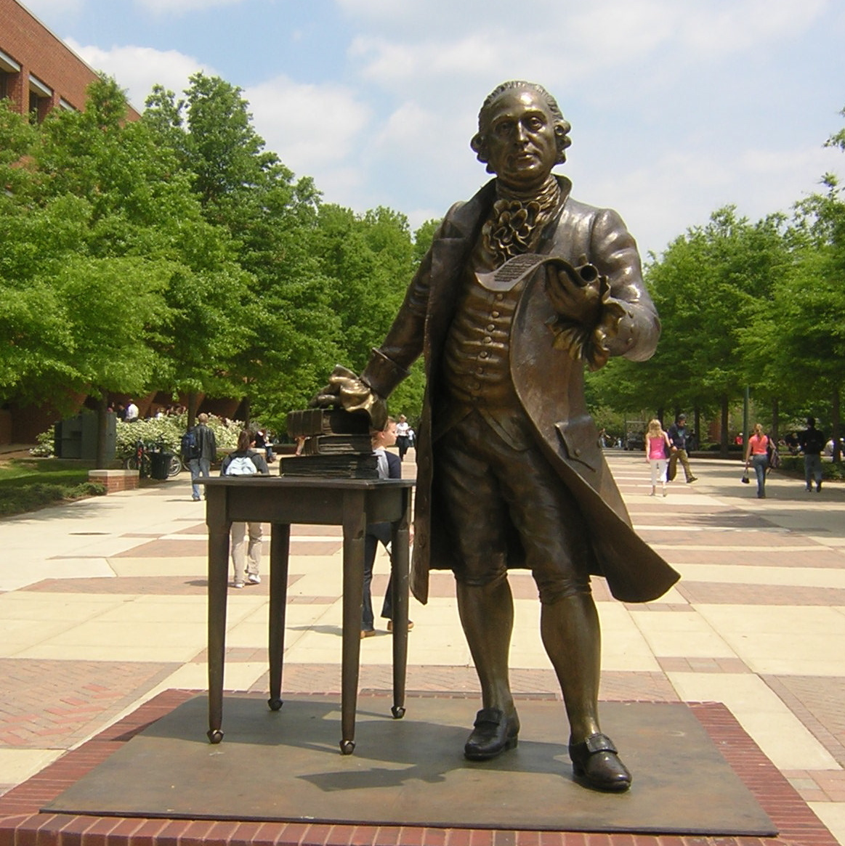

**2018-2019**

**GRADUATE**

**STUDENT**

**HANDBOOK**

**GLOBAL AFFAIRS MA PROGRAM**

**Welcome!**

We are excited that you have chosen the Global Affairs program for your graduate studies and we look forward to working with you throughout your time at Mason. This handbook is intended to provide an introduction to the program and graduate life at Mason. It is by no means comprehensive but hopefully answers your immediate questions and offers enough contacts and links to get you started.

TABLE OF CONTENTS

Global Affairs Curriculum Overview

Academic Policies

Academic Advising

Accelerated Master’s Students

Registration Readiness

Writing Guidelines

Fall 2018 and Spring 2019 Academic Calendar

Financial Matters

Tuition and Payment Information

Financial Aid and Scholarships

Graduate Fellowships

Graduate Research/Teaching Assistantships

Graduate Student Life

Fairfax and Arlington Campus Maps

Getting Started

Email

Mason ID

Parking and transportation

Textbooks

University Libraries

Career Services

Fall 2018 Mason Events

Global Affairs MA Student Resources

Global Affairs Program Contact Information

**Global Affairs: Tomorrow’s Global Citizens**

**Curriculum Overview**

The Master of Arts in Global Affairs is a multidisciplinary program offering students the opportunity to engage in advanced study of a broad range of global issues. Students complete a core curriculum that provides the knowledge and skills necessary to think and act globally. Students also select a specialization for further study within the global arena. The possible specializations reflect the strengths of George Mason University and include global economics and development, governance and public management, international education, and international health. They consist of courses offered by academic departments across the university.

Students take part in a residency abroad, typically two weeks in duration, and complete a capstone seminar. Graduates enter the workforce or move forward in their already-established international and domestic careers in the public sector, non-governmental organizations, and international business.

### NOTE: *A seminar abroad waiver will be granted to those MA students with demonstrated or documentation of anticipated professional international experience for a period not less than nine months working in an international location in the two years preceding or following upon the period of enrollment in the Global Affairs Program. Others with extensive international experience may be granted a seminar abroad waiver at the discretion of the Director. 3 credits of GLOA 710 will be replaced with an additional specialization course, for a total of 30 credits.*

#### Degree Requirements (Catalog Year 2018-2019)

See the University Catalog for requirements for all master's degrees.

Students must maintain a 3.0 cumulative grade point average with no more than two grades below a B. Students pursuing this degree must complete 30 credits.

* Five core courses (15 credits): GLOA 600, 605, 610, 620, 710
* Four courses (12 credits) in a specialization  
  A listing of specializations and the approved courses for each is available on the Global Affairs website, within the Information for Graduate Students section.
  + Students who wish to study abroad in addition to the required residency abroad (GLOA 710 course) may use up to 3 credits toward their specialization and must receive prior approval.
* One capstone seminar (3 credits): GLOA 720

#### Total: 30 Credits

### Core Courses

### GLOA 600 - Global Competencies

Credits: 3

Explores the nature of globalization. Students will understand the characteristics of the current global system; be familiar with key global issues and debates; have an advanced understanding of and appreciation for organizations, languages, cultures in many global contexts; and be better habituated to thinking across disciplinary lines.

**GLOA 605 – Interdisciplinary Research Methods**

Credits: 3

Designed to provide students with an overview of basic techniques in quantitative and qualitative methods with special attention to epistemological and ethical concerns in global studies research. Course includes a discussion of the theoretical assumptions that shape research questions and design, practical exercises in research techniques, and analysis of methodology in practice.

**GLOA 610 - Economic Globalization and Development**

Credits: 3

Focuses on the intersection of countries and firms in the arenas of international trade, investment and finance, as the lenses into understanding better today’s “global” economy:  countries of differing levels of economic development and economic system structure, factors of monetary union and currency disequilibria, trade liberalization or protectionism, market entry, cross-border variables, risk and relations.

### GLOA 620 - Human Systems

Credits: 3

Examines the socio-economic and cultural dimensions of globalization, with particular attention to the Global South. Students will have an advanced understanding of intellectual debates surrounding such topics as human rights, religion, public health, and social movements.

**GLOA 710 - Seminar Abroad**

Credits: 3

Intensive program in a foreign setting focusing on a deep overview of the research specialization of the supervising faculty member. Required pre-departure component to set the intellectual, logistical and culture terms of the abroad period. Locations vary from year to year.

**GLOA 720 - Capstone Research Seminar**

Credits: 3

The final core course requires students to complete a substantial project relevant to their career goals and interests. This course should be taken when students are within nine (9) credits of graduation. Please consult the [Program Coordinator](mailto:globalma@gmu.edu) prior to registering.

**Specializations**

A central feature of the master's degree in global affairs is the interdisciplinary specialization. The core courses and your program advisors will help you to link your interests with one particular specialization. Students that wish to pursue an individualized specialization also work with the program advisors to develop a topic and course list that is appropriate.

Please note that not all specialization courses are offered every year and some may have prerequisite requirements that must be fulfilled prior to enrollment. The applicable courses for each specialization can be found on the Global Affairs website, within the Information for Graduate Students section.

* Global Conflict and Security
* Global Culture and Society
* Global Economics and Development
* Global Education
* Global Governance and Public Management
* Global Health
* Global Media and Technology
* Global Population and Geography
* Individualized Specialization

**Academic Policies for Graduate Students**

University and College Policies

* **Classification** – Graduate students are considered full time if they are enrolled in at least 9 graduate credits per semester or hold a full-time assistantship (total 20 hours a week) and are enrolled in at least 6 graduate credits per semester.
* **Credit Limit** – Graduate students may enroll in a maximum of 12 credit hours per semester.
  + Students who wish to enroll in additional hours must complete a Graduate Course Overload Request form. Students must first obtain permission from their graduate program director. The form will be forwarded to the Registrar’s Office for final processing and the student will be able to register for additional credit hours via Patriot Web.
* **Time Limit** – Master’s degree students have six years from the time of first enrollment as a degree-seeking student to complete their degrees. International students attending in F-1 or J-1 status also have more restrictive time limits; contact the Office of International Programs and Services for information.
  + Permission to Re-Enroll – Permission to re-enroll in a program must be obtained by all master’s students who have failed to enroll in at least 1 credit of course work for two or more consecutive semesters at Mason. The Graduate Application for Reenrollment form is available at registrar.gmu.edu. The form must be approved and signed by the graduate program director.
    - Students who are given permission to re-enroll following an absence from Mason may not count the six-year time limit as beginning on the date of re-enrollment. Students who will not meet published time limits because of circumstances beyond their control may petition for an extension.
* **Registration**
  + Consortium Registration – Enrolled, degree-seeking graduate students may be eligible to take courses through the Consortium of Universities of the Washington Metropolitan Area. Participation is limited to courses that are approved by the student’s department chair and dean, apply to the student’s program of study, are not offered during that semester at Mason, and have space available at the visited institution. Graduate students may take one consortium course per semester, with a career maximum of 6 credits. Credit earned through the consortium is considered resident credit, so grades count in the Mason GPA. See: http://registrar.gmu.edu/topics/washington-consortium/
  + Course Withdrawal – For graduate students, withdrawal after the last day to drop a course requires approval by the student’s academic dean, and is permitted only for nonacademic reasons that prevent course completion.
  + Selective Withdrawals are not permitted for graduate students.
  + Repeating a Course – Graduate students who have passed a course with a satisfactory grade (B-) are not permitted to repeat the course for replacement credit unless the academic program specifies a higher minimum satisfactory grade. Students must obtain permission from their program to repeat a course in which they have earned an unsatisfactory grade.
* **Grading**
  + Although a B- is a satisfactory grade for a course, students must maintain a 3.00 average in their degree program and present a 3.00 GPA on the courses listed on the graduation application.
  + Academic Warning – A notation of academic warning is entered on the transcript of a graduate student who receives a grade of C or F in a graduate course or while a grade of IN is in effect.
  + Academic Dismissal – A degree-seeking graduate student is dismissed after accumulating grades of F in two courses or a total of 9 credits of unsatisfactory grades (C or below) in graduate courses.
* **Graduation** – Students must be registered during the semester in which they intend to graduate. Graduate Intent must be filed through Patriot Web according to the semester deadlines. After filing intent, students should update their current mailing address, phone number, and email address in Patriot Web and ensure all "IP" (In Progress) and "IN" (Incomplete) grades are resolved by the end of the semester.

Global Affairs Program Policies

* **Registration**
  + The Global Affairs core courses are offered each fall and spring semester. With the exception of the GLOA 710, Seminar Abroad, we do not offer the core courses in the summer. Students that wish to take courses in the summer are encouraged to register for specialization courses.
  + Courses Outside of CHSS – The specialization list will include instructions for registration for each department. Some require permission; others do not.
  + Students are encouraged to register as soon as possible after registration opens.
* **Specializations** – Students complete a total of 12 credits for their specialization. Courses must come from at least two departments or programs (courses need at least two different prefixes in the list of courses you take).
  + Special Topics Specialization Courses – each semester, a number of special topics courses are available for the specializations. A list will be published when the schedule of classes for the next semester becomes available and will be updated if the schedule changes.
  + Your selected specialization classes may not be immediately recognized in your Patriot Web degree audit for your chosen specialization. If this is your situation just contact Stephanie (globalma@gmu.edu) and she will move the course into your specialization.
  + Individualized Specialization – if you wish to design your own specialization you must submit a one-page proposal that includes a description of the specialization, how it differs from the pre-determined specializations, and propose a list of courses to satisfy the specialization. You should suggest a minimum of ten courses and the proposal should include how each course is relevant.
* **Seminar Abroad, GLOA 710** – Offered in Winter and Summer terms. Please see website for waiver policy.
  + You may participate in additional study abroad programs with prior approval of the program director. No more than 3 credits may transfer back into the program and coursework must be global in nature.
* For a graduate semester abroad program, it is permitted to transfer 9 credits from the Oxford Honor’s program.

*Please note: This is not a comprehensive list! The University Catalog should be consulted for additional student policies:* [*http://catalog.gmu.edu/*](http://catalog.gmu.edu/)

**Academic Advising for MA Students**

Stephanie Lister, the Global Affairs Graduate Coordinator, can assist you with:

* Planning for your Global Affairs Core/Specialization Classes each semester
* Issuing Global Affairs core course overrides
* Answering questions related to degree progress and any issues with how courses are displayed in your degree evaluation

Your faculty advisor can assist you with determining your MA specialization and suggestions for research and professional development.

Find your faculty advisor based on the first letter of your last name:

* A – D: Dr. Jennifer Ashley

* E – L: Dr. Lisa Breglia

* M - P: Dr. Nicholas Hultin
* Q - Z: Dr. Byunghwan Son

**How to Check your Degree Evaluation**

Along with advisor consultation, all students must track their progress through the online degree evaluation, [Degree Works](http://registrar.gmu.edu/students/degree-evaluation/degree-works/), in Patriot Web. The degree evaluation is the audit maintained by the Registrar's Office which tracks course completion. It should be checked each semester before and after registration to ensure that enrolled courses are meeting requirements.

**Academic Advising for Accelerated MA Students**

All new/transitioning Accelerated MA students will have a faculty advisor in addition to the graduate coordinator. Accelerated MA students will be notified of their faculty advisor the week before classes start.

Along with advisor consultation, all students must track their progress through the online degree evaluation, [Degree Works](http://registrar.gmu.edu/students/degree-evaluation/degree-works/), in Patriot Web. The degree evaluation is the audit maintained by the Registrar's Office which tracks course completion. It should be checked each semester before and after registration to ensure that enrolled courses are meeting requirements. Students should contact Stephanie at [globalma@gmu.edu](mailto:globalma@gmu.edu) with any questions related to how courses are displayed in Degree Works for the BA in Global Affairs.

* Your faculty advisor will help you to understand the expectations of the graduate level classes and contribute to your success in the MA program. Your faculty advisor will meet with you once during the Fall and Spring semester to address challenges/questions you might have with the program.
* After your graduation semester from the BA, during the semester in which you transition to the MA program, you will receive an Accelerated MA Transition Evaluation from your faculty advisor.
* Transitioning students will receive an evaluation based on their first two semesters of graduate level work, with a follow-up meeting from faculty advisor during the first two weeks of the Fall/Spring semester.

**ACCELERATED MASTER’S STUDENTS**

In order to transition from the Accelerated Master’s Pathway to the Master’s in Global Affairs, you are required to submit a Bachelor’s/Accelerated Master’s Transition Form (<http://registrar.gmu.edu/wp-content/uploads/BAMT.pdf>). The Graduate Coordinator will submit this form on your behalf to the Office of Graduate Admissions and Registrar’s Office and obtain the appropriate signatures. The form will be submitted during your final BA semester, after the last day to drop for the semester.

Once your form has been processed by the Office of Graduate Admissions, you will receive your final admissions offer to the Master’s in Global Affairs.

For any questions, please e-mail the Graduate Coordinator at [globalma@gmu.edu](mailto:globalma@gmu.edu).

**Registration Readiness**

Enrollment for all GLOA core courses is controlled. You will need an override in order to register. We control the enrollment so everyone who needs a spot in each class is accommodated. If you cannot register for class you believe you need, just contact globalma@gmu.edu.

Each semester, we need to know if you will be a full or part time student, and which classes you hope to complete the following semester. You can arrange an advising appointment or e-mail Stephanie at [globalma@gmu.edu](mailto:globalma@gmu.edu). We need to know your enrollment plans so you have the correct overrides for GLOA core courses for when registration opens in Patriot Web.

Each semester, in October and March, we will host an evening registration readiness event. At this event you can

* Receive advising on core and specialization courses
* Talk with other students and get their insider tips and advice on courses and professors
* Make short term plans for next semester and long term plans to get you on the path the graduation

**Paper Guidelines**

All written work submitted for a grade in GLOA courses (GLOA 600, GLOA 605, GLOA 610, GLOA 620, GLOA 710, GLOA 720, and any GLOA 599 Special Topics courses) must follow the guidelines below. If an individual professor offers conflicting instructions, you should follow them instead. In the absence of such instructions you should follow these guidelines to ensure that the work you produce during your graduate career is consistent and professional.

**Paper Format:**

1. Papers must be in MS Word format.
2. Papers must be double-spaced and have 1” margins on all sides. The paper size must be set to US Letter size.
3. The font size must be 11 or 12. Use a standard font such as Times New Roman, Calibri, Computer Modern, or Helvetica.
4. The paper should not have a cover page but the first page of the paper must include all of the following information:
   1. Title of the paper
   2. Student name and G#
   3. Class for which it is submitted
   4. Term and year
   5. Date of submission
5. Each subsequent page of the paper must have a footer that includes:
   1. Student last name
   2. Page number

**Writing Style:**

Since this is a graduate level class, professional writing is expected. This means proper organization, no grammatical mistakes, and no typos. Please be especially mindful of the following mistakes that our faculty members often see in papers (including MA-level papers!):

1. Improper capitalization of words. You should capitalize proper names and titles when you are referring to a specific person (e.g. Germany, President Obama). You should not capitalize for emphasis, nor capitalize jobs or positions (you run “for president,” not “for President”). A helpful guide to capitalization is here: <https://www.grammarly.com/handbook/mechanics/capitalization/>
2. Commonly mixed-up words, including, but not limited to the following (a helpful list of commonly mixed-up words is available here: <http://www.stlcc.edu/Student_Resources/Academic_Resources/Writing_Resources/Grammar_Handouts/commonly_confused_words.pdf)>:
   1. There, their, and they’re
   2. Affect, effect
   3. Accept, except, expect
   4. Loose, lose
   5. Principal, principle
3. Subject-verb disagreements. See here: <http://bethune.yorku.ca/writing/s_v/>
4. Passive voice. Passive voice is not a grammatical mistake but it is not recommended in academic writing as it is often vaguer than active voice. For more, see here: <http://writingcenter.unc.edu/handouts/passive-voice/>.
5. Overwrought language. Keep your language straightforward and avoid fancy words when a simpler and more common word will suffice (e.g. why say “utilize” when you can say “use”?).
6. The royal we. In most social science and humanities fields, it is recommended to use the first person pronoun. “I argue in this paper” is clearer and more direct than “we argue in this paper” (or passive construction: “in this paper it will be argued”).
7. Abruptly starting a new section of a paper rather than smoothly transitioning into a new paragraph when you want to move from one idea to the next.
8. Overly long paragraphs. The topic sentence for each paragraph should be the argument of that paragraph. All sentences that follow should be in support of the one key point that you are developing in that paragraph. If you find yourself writing a paragraph that is a page-long, that is a good sign that you have failed to provide a tight enough focus for your paragraph.
9. 1 or 2 sentence paragraphs. A well-structured paragraph (with a minimum of four sentences) can do a lot of work for your paper in terms of furthering your argument, laying our evidence, and helping you draw conclusions. For a great resource on improving your paper by writing better paragraphs, see here: <http://writing.wisc.edu/Handbook/Paragraphing.html>
10. Lack of argument. A good argument is one that links the old (previous research) with the new (your unique analytic intervention).

Also note that the George Mason Writing Center (<http://writingcenter.gmu.edu)> is available to graduate students as well as undergraduates. If you wish advice to improve your writing, we encourage you to make use of this resource.

**Citation and References:**

The default citation format for the program is Chicago (Author-Date) as set forth in the Chicago Manual of Style. We strongly recommend that you use a reference program to help you ensure that your citations are correct. One such program, Zotero, is freeware, is developed at George Mason, and is supported with workshops by the library. More information is at <https://www.zotero.org/>. There are plenty of alternatives for Mac and PC, and you can also use a website such as <https://www.citationmachine.net/> to produce correct citations. A helpful guide to Chicago is here: <http://www.chicagomanualofstyle.org/tools_citationguide.html> (make sure to follow the Author-Date instructions, not the Notes and Bibliography ones). An additional citation resource is provided by Mason’s library: <http://library.gmu.edu/ask/citing>.

When using Chicago (A-D) and other in-text citation formats, including APA, you should keep footnotes and endnotes to a minimum and not for referencing. References (or citations) are included in the text, following any quote marks and before any punctuation marks (an in-text citation never goes after the period, it always goes before it). If you mention the author in the text, you do not need to include his or her name in the succeeding citation.

Examples of correct in-text citations:

“UNAMIL’s success seems to confirm that UN mandates and commitment are two intricately linked factors” (Brattberg 2012, 161).

According to Brattberg, “UNAMIL’s success….linked factors” (2012, 161).

The following are examples of different Chicago-formatted citations:

*Journal article:*

Brattberg, Erik. 2012. "Revisiting UN Peacekeeping in Rwanda and Sierra Leone." *Peace Review* 24(2): 156-62.

*Book (single-authored):*

Drezner, Daniel W. 2011. *Theories of International Politics and Zombies.* Princeton, NJ: Princeton University Press.

*Book chapter:*

Shepler, Susan. 2016. “Sierra Leone, Child Soldiers and Global Flows of Child Protection Expertise.” In *The Upper Guinea Coast in Global Perspective*, edited by Jacqueline Knörr and Christoph Kohl, 241-251. Oxford, UK: Berghahn Books.

Please note that while Chicago covers most kinds of sources that you might want to cite in a paper, there always are unusual and uncovered items (court cases, treaties, and other legal documents, for example, are notoriously tricky to cite). If Chicago does not provide a template, you should include as much information about the source as needed to enable somebody else to locate it (also ask your professor).

**Fall 2018 Important Dates**

**(for all academic calendars see:** [**http://registrar.gmu.edu/calendars/**](http://registrar.gmu.edu/calendars/)**)**

**First day of classes**; Payment Due Date Mon Aug 27

Labor Day, university closed Mon Sept 3

**Last day to add classes Tues Sept 4**

**Final Drop Deadline** Mon, Sept 10 at midnight

Student Self-Withdrawal Tues Sept 11- Sun Sept 30

Columbus Day recess  
(Monday classes meet Tuesday. Tuesday classes do not meet.) Mon Oct 8

Thanksgiving recess Wed Nov 21 -   
 Sun Nov 25

Last day of classes Sat Dec 8

**Reading Days\*** Mon Dec 10-Tues Dec 11

**Exam Period** Wed Dec 12 -   
Wed Dec 19

**Degree Conferral Date** Sat Dec 22

*Reading days provide students with additional study time for final examinations. Faculty may schedule optional study sessions on Reading Days, but regular classes or exams may not be held.

For additional details, see: <http://registrar.gmu.edu/calendars/>

**Spring 2019 Important Dates**

Martin Luther King Day (University closed) Mon Jan 21

**First day of classes**; Payment Due Date Tues Jan 22

**Last day to add classes** Tues Jan 29  
 **Final Drop Deadline** TBD

Spring Break Mon Mar - 11  
 Sun Mar - 17

Last day of classes Mon May 6

**Reading Day\*** Tues May 7

**Exam Period** Wed May 8 –

Wed May 15

**Commencement and Degree Conferral Date** Fri May 17-

Sat May 18

*Reading days provide students with additional study time for final examinations. Faculty may schedule optional study sessions on Reading Days, but regular classes or exams may not be held.

For additional details, see: <http://registrar.gmu.edu/calendars/>

**Financial Matters**

* Tuition and Payment Information
* Financial Aid and Scholarships
* Graduate Fellowships
* Graduate Research/Teaching Assistantships

**Tuition and Payment Information**

For complete information, visit: https://studentaccounts.gmu.edu/

George Mason University

Fall 2018 Graduate Tuition Rates

http://studentaccounts.gmu.edu/wp-content/uploads/Fall2018Graduate.pdf

College of Humanities and Social Sciences

In-State Tuition: $489.00 per credit hour

Out-of-State Tuition: $ $1,346.75 per credit hour

* Education Resource Fee: assessed per semester – less than seven credits $60; seven credits or greater $100.
* Graduate New Student Fee: This is a mandatory, non-refundable, one-time fee. The fee is charged to the account of every newly admitted, degree-seeking student at the time of registration, regardless of orientation attendance or enrollment status. The new student fee is $60.00.
* Mandatory Student Fee: This is a mandatory fee based on credit enrollment. The Mandatory Student Fee supports the maintenance of facilities and buildings, auxiliary services, intercollegiate athletics, campus shuttle, academic services, student activities, and health services. Students are charged $141.75 per credit. For more information, please refer to Mandatory Student Fees in the Student Accounts Office website, Tuition & Fees

**Payment Information**

Payment Deadline

Payments received at the Cashier's Office by 4:30 PM on any business day will be considered as that day's business. Payments may be made online using the Bill and Payment System until 10:30 PM. Please see Patriot Web, to confirm receipt of payment and balance due. Payment is due the first day of the semester.

Cashier's Office: <http://cashiersoffice.gmu.edu/>

Pay Online

Online payments are made using the Bill and Payment System. This system allows students to manage their account activity online, view bills, make payments, and set up authorized users (parents, employers, etc). Authorized users only have account management access; academic information is not available through this system. Payment plans are also available to pay your balance in installments.

Bill and Payment system: <https://secure.touchnet.com/C20788_tsa/web/login.jsp>

Modes of Payment

* Web: Bill and Payment System
* Window: Cashier's Office, 1501 Student Union I, 9:00 AM - 4:30 PM
* Drop Box (no cash payments): Outside Cashier's Office, 1501 Student Union I
* Mail:

George Mason University

Cashier's Office, MSN 2E1

4400 University Drive

Fairfax, VA 22030

Allow 14 days for delivery, and confirm receipt by accessing Patriot Web or the Bill and Payment System.

Methods of Payment

* Cash: At Cashier's Office window only
* Check: Web, window, mail, or drop box. Make payable to GMU, student G# written on front. Third-party checks not accepted. Must be payable in US dollars. For each check returned by the bank unpaid, a $50 return check fee will be charged.
* Credit Card (subject to credit approval): Web only. MasterCard, American Express, or Discover Card. There is a 2.75 percent convenience fee for credit card payments. This fee is nonrefundable.

**Payment Options**

Mason Payment Plan

Mason payment plans are available online for students who need to budget their accounts. A down payment, which is the first payment plus a $25 contract fee, is required at the time of enrollment. The contract fee is nonrefundable. Study Abroad/Global Education and international student health insurance fee payments cannot be deferred. Failure to pay the deferred balance by the due date will result in financial hold, a late fee of 10% (up to $125), collection activity, and may prevent future eligibility of the payment plan. To view the plans available for enrollment, please visit the Bill and Payment System.

Third Party Billing Authorizations

Students using a third party billing authorization will be charged a $25 processing fee. Students may receive an individual billing statement. Students must provide the third party authorization or government training voucher to the Third Party Billing Office, Student Union Building I, Suite 1600, or fax to 703-993-2460, before the student's individual due date, which is based on their registration date.

Check Important Dates (http://studentaccounts.gmu.edu/dates.html) for the last day third party payment authorizations will be accepted. Students are ultimately responsible for any defaults in payments by the sponsoring agency. For more information, please navigate to Third Party Billing Office web site: <http://studentaccounts.gmu.edu/thirdparty/>.

**Financial Aid and Scholarships**

For complete information, visit: <http://financialaid.gmu.edu/>

Financial Aid Counselors (based on last name): <http://financialaid.gmu.edu/contact-us/>

Students who need additional financial support beyond tuition waivers, fellowships or assistantships should apply for financial aid by completing a Free Application for Federal Student Aid (FAFSA) a minimum of 30 days prior to the start of your program.

* Free Application for Federal Student Aid (FAFSA): <http://www.fafsa.ed.gov/>
  + Must be completed a minimum of 30 days prior to the start of your program.
* Federal financial aid programs: <http://studentaid.ed.gov/>
* Financial Aid for International Students: https://www2.gmu.edu/admissions-aid/financial-aid/types-students

**Scholarships**

<http://financialaid.gmu.edu/scholarships/>

**Fellowships**

<http://gradfellows.gmu.edu/>

**Assistantships**

Source: <http://gradlife.gmu.edu/financial-matters/>

Assistantships are university employment positions held by graduate students who have full-time enrollment, a minimum 3.0 GPA, and are in good academic standing. Assistantships are available in the following three categories:

Graduate Teaching Assistantship: students will participate in the instruction, advising, and evaluation of undergraduates under faculty supervision.

Graduate Professional Assistantship: a non-teaching, non-research assistantship during which students will perform work in which they primarily gain experience, practice and guidance in relation to their academic program and that is significantly connected to their fields of study and career preparation.

Assistantship opportunities are listed in a variety of places including: the Mason Jobs website, Career Services’ Handshake site, and in academic departments. Students may also contact their advisors for assistantship information and opportunities.

* Mason Jobs website: <https://jobs.gmu.edu/>
* Career Services, Handshake, https://careers.gmu.edu/handshake

**Graduate Student Life**

Mason’s Office of Graduate Student Life provides a wealth of information for new and continuing graduate students. They are dedicated to supporting the success of Mason graduate students by:

* Providing community-building, professional development, and personal development programs
* Connecting graduate students to campus resources
* Identifying and advocating for graduate student needs

Graduate Student Life operates the Graduate Student Center and lounge in the Johnson Center, rooms 310 and 311E. The Center offers a multi-purpose space for the exclusive use of graduate students. The Center features a quiet study room with individual desks, an open lounge, and wireless internet access. The lounge area offers couches, chairs, tables, and a campus phone.

<http://gradlife.gmu.edu/>

Mason Graduate and Professional Student Association (GAPSA)

GAPSA seeks to unite graduate students and establish a forum through which graduate and professional students are able to address issues, advocate for the greater good, grow professionally, and socialize with one another.

<https://www.facebook.com/masongapsa>

Contact: [gapsa@gmu.edu](mailto:gapsa@gmu.edu)

Fairfax and Arlington Campus Life

Both the Fairfax and Arlington campuses offer a wide variety of events that appeal to graduate students. Arlington campus events, typically planned by the School of Public Policy or the School for Conflict Analysis and Resolution, are announced to Global Affairs students via the listserv. Fairfax campus events will also be announced through the listserv and can be found by visiting: http://gradlife.gmu.edu

**CAMPUS MAPS**

Fairfax Campus:

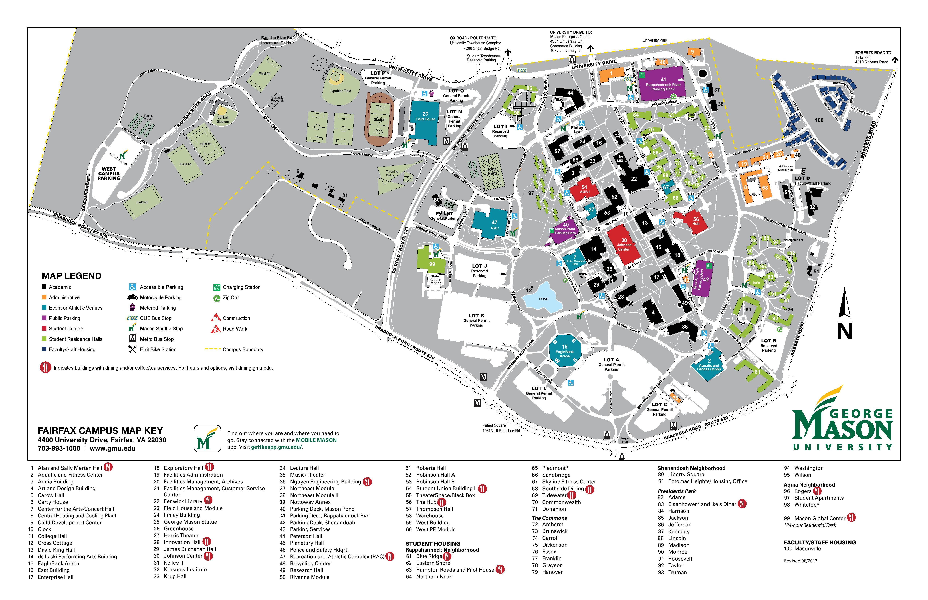

Arlington Campus:

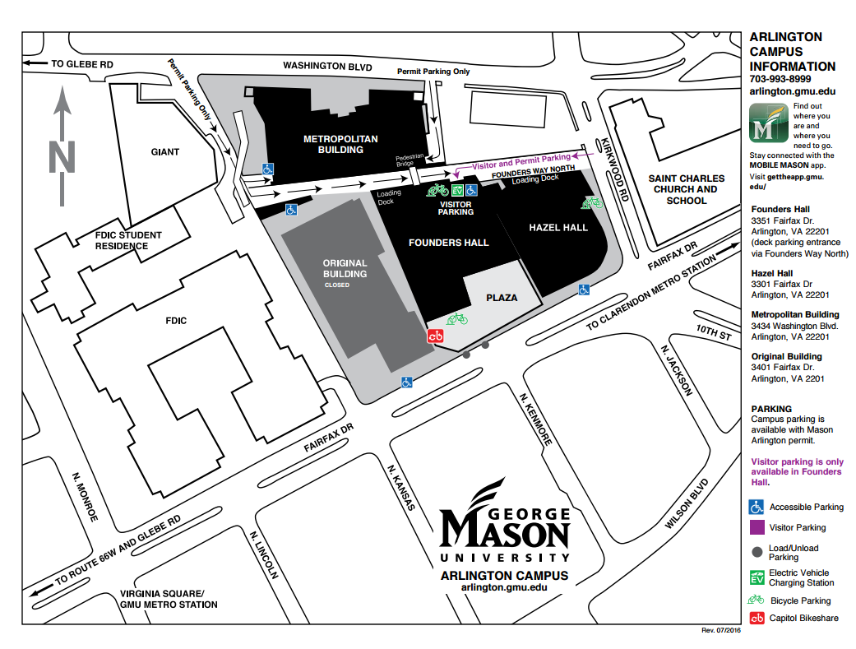

**Getting Started**

Email

All students must activate and regularly check their GMU email account. Official email from university faculty, staff and administration will only be sent to your GMU account ([username@masonlive.gmu.edu](mailto:username@masonlive.gmu.edu)). The Global Affairs program regularly sends messages to the graduate student listserv and your membership to this list is tied to your GMU email account.

For information about your MasonLive email account, including set up instructions, see: http://masonlive2.gmu.edu/instructions.cfm

Mason Identification Card (Mason ID)

All students must obtain a Mason ID card. In addition to serving as your library card, your Mason ID can be used for:

* Meal Plan and Mason Money
* Copying and computer lab printing
* Discounts/priority seating at specified Patriot Center events
* Free Cue Bus rides
* Accessing the Field House (athletics complex)
* Free entry to the Aquatic and Fitness Center (full-time students)
* Free entry to specified Concert Hall performances (full-time students)
* Free entry to Johnson Center Cinema (full-time students)

To obtain your ID, bring a form of picture ID and your Gnumber to the Mason Card Office: Student Union Building I (SUB I), room 1203 (ground floor near the Cashier’s Office).

Parking and Transportation

All vehicles parked on property owned or operated by GMU must display a valid parking permit. Parking options include general and reserved surface lots and parking garages, and permits range in cost from $50 (West Campus spring permit) to $190 (spring and summer general lot permit).

For current rates, visit: <http://parking.gmu.edu/permitfinerefundrates.html>

Parking at the Arlington campus is less prevalent and requires a different permit than that used at the Fairfax campus. More student spaces are available at the Arlington campus after 6:00pm. For complete information on parking at the Arlington campus, visit: <http://parking.gmu.edu/arlparkingoptions.html>

Both the Mason and Arlington campuses are easily accessible via public transportation. Information on transportation options such as the Mason Shuttle, Cue Bus, Fairfax Connector and Metro can be found on the website of the Transportation Department: <http://transportation.gmu.edu/>.

Textbooks

Textbooks for courses held at the Fairfax campus may be found on the Fairfax bookstore website: <http://gmu.bncollege.com/>. Textbooks for courses held at the Arlington campus may be located through the Arlington bookstore website: http://arlington.gmu.edu/student-resources/bookstore/.

If textbooks for your course are not listed on the bookstore websites, you will likely receive an email (to your GMU email account) from your professor, prior to the start of classes, with the book list. If you do not receive an email your professor, you will receive the booklist on the first day of class with your syllabus.

**University Libraries**

<http://library.gmu.edu/>

Mason has a total of five libraries between the three distributed campuses – Fairfax, Arlington, and Prince William:

Arlington Campus Library

Founders Hall - Room 201, MS 1D1

3351 Fairfax Drive

Arlington, VA 22201

Circulation Desk: 703-993-8188 / Reference Desk: 703-993-8230

Fax: 703-993-8142

TTY: 703-993-4970

Email: [aclref@gmu.edu](mailto:aclref@gmu.edu)

<http://library.gmu.edu/libinfo/acl.html>

Fenwick Library

4400 University Dr., MSN 2FL

Fairfax, VA 22030

General Information Line: 703-993-2250

Circulation Desk: 703-993-2240 / Reference Desk: 703-993-2210

<http://library.gmu.edu/libinfo/fenwick.html>

Gateway Library

4400 University Dr., MSN 1A6

Fairfax, VA 22030

Circulation desk: (703) 993-9060 / Reference desk: (703) 993-9070

TTY: (703) 993-3992

http://library.gmu.edu/locations/gateway

Mercer Library, SciTech Campus

10900 University Blvd., Occoquan Bldg., Room 104

MSN 4E6

Manassas, VA 20110-2203

Fax: 703-993-8349

Circulation Desk: 703-993-8340 / Reference Desk: 703-993-8342

TTY: 703-993-8365

http://library.gmu.edu/locations/mercer

George Mason University Law Library

3301 N. Fairfax Drive

Arlington, VA 22201-4426

Phone: 703-993-8120

Fax: 703-993-8113

<http://www.law.gmu.edu/library>

Students are highly encouraged to attend a library tour or workshop (in-person or online) to familiarize themselves with the available resources. The schedule can be found at: http://library.gmu.edu/locations/fenwick/tour.

Consortium Loan Service

Students may also utilize the Consortium Loan Service, a feature of Mason's participation in the Consortium of Universities of the Washington Metropolitan Area.

Taken from http://library.gmu.edu/use/ill:

Mason students, faculty, and staff may borrow books and have articles sent directly from other WRLC (Washington Research Library Consortium) libraries rather than using the standard interlibrary loan procedures common to all libraries. This direct borrowing service allows students and faculty to receive books and articles from other WRLC libraries more quickly (generally within 2 business days). Please note: students and faculty requesting items to be sent to the Prince William campus need to allow somewhat more time for delivery of the item(s).

**Career Services**

Mason has an outstanding Career Services office that is ready to assist you with your internship and job search needs. Industry Advisors and general career counselors are available by appointment, and the office holds regular events that are open to all students.

Career Services is located in Student Union Building I (SUB I), room 3400.

Phone: (703) 993-2370 / Email: [careers@gmu.edu](mailto:careers@gmu.edu) / Web: <http://careers.gmu.edu/>

**Fall 2018 Mason Events**

Below is just a snapshot of upcoming events that may be of interest to Global Affairs graduate students:

1. **2018 Welcome Week Part-Time Job Fair**

**Wednesday, August 29, 2018   
Johnson Center, Dewberry Hall  
11 a.m. - 2 p.m.**

1. **Press Pass: Student Media’s Fall Open House**

Thursday, August 30

4:00pm - 6:00pm

The Hub 1201

Interested in Media Production? Radio? Television? Journalism? Student Media is the place for you. We are the voice of the student body and home to Mason’s student-run newspaper, radio station, television network, literary journals, magazines, and more. Join us for our Fall Open House to learn how to get involved, meet new people, and enjoy some free food!

1. **IVth Night Welcome Back Carnival**

Thursday, August 30

4:00-8:00 pm

An outdoor carnival on Wilkins and East plaza with inflatables, FREE Mason Patriot FIGHT SONG t-shirts, food, music, and giveaways. Brought to you by Patriot Activities Council (PAC). FREE Event with Mason ID.

1. **Blanket Bingo and Outdoor Movie featuring Avengers: Infinity Wars**

Friday, August 31

7:30-11:00 pm

Merten Lawn

BYOB (Bring Your Own Blanket) and play BINGO for some awesome prizes, and then stay to watch Avengers: Infinity War starting at 9:00pm. Brought to you by Welcome2Mason and Residence Life!

1. **GetConnectedFair**

Wednesday, September 5

11:00 am-2:00 pm

Wilkins Plaza

The academic year's LARGEST involvement fair is coming soon! Come join departments, offices, community partners, registered student organizations, and mason recreation and learn how to get involved!!!!

1. **Handshake Launch Party**

Thursday, September 6

11:00 am-2:00 pm

The Hub Ballroom

Get to know Handshake (and Career Services) at the Launch Party! We'll be in the Hub Ballroom with food and prizes. Stop by to tour Handshake, complete your profile, and get your questions answered. Practice your handshake at our Handshake booth and pose in the Handshake chair at our photo booth! Career development is serious, but it doesn't have to be boring! Don't miss this chance to connect with Career Services in this fun, no-pressure environment.

1. **Gradstravaganza**

Gradstravaganza 2018

September 7, 2018

All new and continuing Mason graduate students are invited to Gradstravaganza, Mason’s annual graduate student welcome event!

## 3:30-5:00pm: Mini-Workshops in the Johnson Center (Fairfax Campus)

## 5:30-7:30pm: Picnic at The Hub (Lawn, Patio, and Indoor Spaces) (Fairfax Campus)

All new and continuing Mason graduate students are invited to Gradstravaganza, Mason’s annual graduate student welcome event! Join fellow Mason grad students for FREE food, mini-workshops highlighting strategies for success in graduate school, connections with campus resources, games, and giveaways, including special Mason Grad Student t-shirts! Families are welcome! Remember to bring your Mason student ID with you. Brought to you by Graduate Student Life, Student Involvement, the Office of the Provost, Mason Recreation, the Graduate and Professional Student Association (GAPSA), and Mason Parking Services.

1. **2018 Fall Career Fair**

Mason Career Services

Wednesday, October 3 and Thursday, October 4, 2018

11 a.m.-4 p.m.

Johnson Center, Dewberry Hall

**Global Affairs MA Student Resources**

GLOA MA Facebook Group (You have been invited to join. E-mail Stephanie at [globalma@gmu.edu](mailto:globalma@gmu.edu) to request access).

* Connect with other Global Affairs MA Current Students and Alumni
* Find out about important updates

Global Affairs Twitter (https://twitter.com/gmu_gloa)

Global Affairs MA Digest – Sent on Tuesdays

1. Find out about updates from Global Affairs and Mason
2. Upcoming Global Affairs and Mason Events
3. Resources for students

**Fairfax Campus Resources**

Office of the University Registrar (703-993-2441, [registrar@gmu.edu](mailto:registrar@gmu.edu), registrar.gmu.edu)

Student Accounts (703-993-2484, [saccount@gmu.edu](mailto:saccount@gmu.edu), studentaccounts.gmu.edu)

University Life (703-993-8760, https://ulife.gmu.edu/)

**Arlington Campus Resources**

University Life (703-993-8984, [ularl@gmu.edu](mailto:ularl@gmu.edu), <https://ularlington.gmu.edu>)

**Global Affairs Program Contact Information**

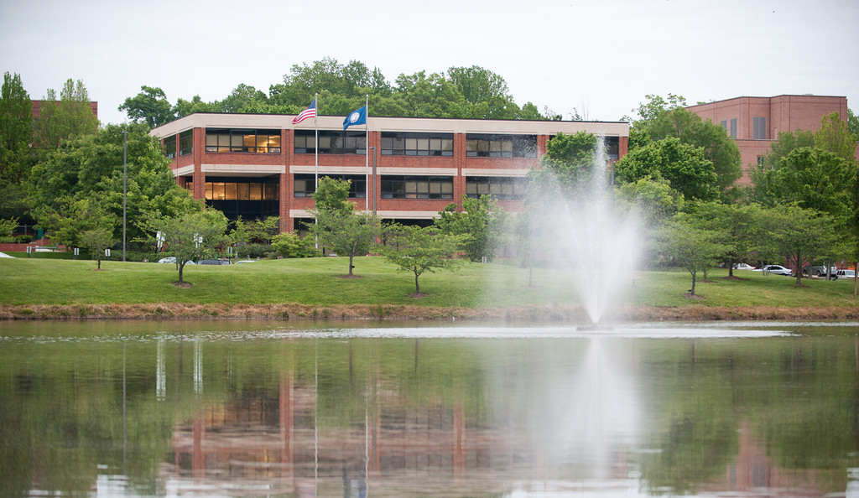

**James Buchanan Hall (formerly Mason Hall), Room D215**

George Mason University

4400 University Drive, 6B4

Fairfax, VA 22030-4422

Phone: 703-993-9185

Fax: 703-993-1244

[gloa@gmu.edu](mailto:gloa@gmu.edu) (Undergraduate)

[globalma@gmu.edu](mailto:globalma@gmu.edu) (Graduate)

<http://globalaffairs.gmu.edu>

**Faculty and Staff**

Dr. Lisa C. Breglia, Director

[lbreglia@gmu.edu](mailto:lbreglia@gmu.edu)

Dr. Jennifer Ashley

[jashley4@gmu.edu](mailto:jashley4@gmu.edu)

Dr. Johanna Bockman

[jbockman@gmu.edu](mailto:jbockman@gmu.edu)

Dr. Niklas Hultin

[jhultin@gmu.edu](mailto:jhultin@gmu.edu)

Dr. Byunghwan Son

[bson3@gmu.edu](mailto:bson3@gmu.edu)

Dr. Kathalene Razzano

[krazzano@gmu.edu](mailto:krazzano@gmu.edu)

Stephanie Lister, Graduate Coordinator

[slister1@gmu.edu](mailto:slister1@gmu.edu)

Erika Marquina, Academic Advisor (Undergraduate)

[emarquin@gmu.edu](mailto:emarquin@gmu.edu)